

USB 2.0 to SATA / IDE Converter Adapter

The USB 2.0 to SATA/IDE combo adapter allows users to use IDE or SATA hard drives over a USB 2.0 connection. It works with most IDE (up to ATA 133) and SATA 1.0a devices. This device provides a simple, yet powerful data transfer and backup solution.

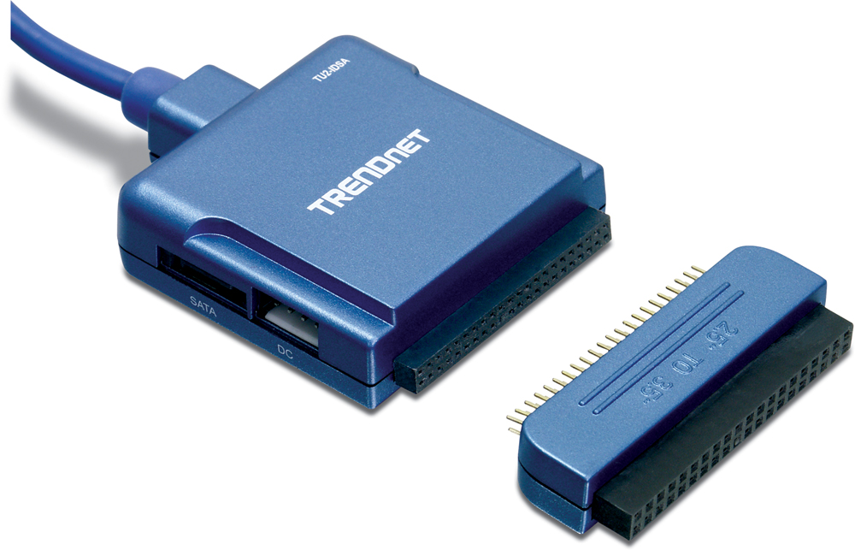

TU2-IDSA (Version V1.0R)
Features
- Compliant with USB 2.0 and SATA (Serial ATA) 1.0a Specifications
- Compliant with USB Mass Storage Class Bulk-Only Transport Specification
- Supports combo connectors IDE (40pin & 44pin) for 2.5” / 3.5” /5.5” IDE & SATA devices
- Turns an internal IDE/SATA hard drive or CD/DVD-ROM into an external USB device
- Operates IDE and SATA devices simultaneously
- Compliant with Windows 98SE/ME/2000/XP/2003 Server Mac OS X
- Plug & Play for easy Installation
- 2-Year Warranty
Specifications Converter Solution for TU2-IDSA
Hardware
Interface | USB 2.0, 1.1  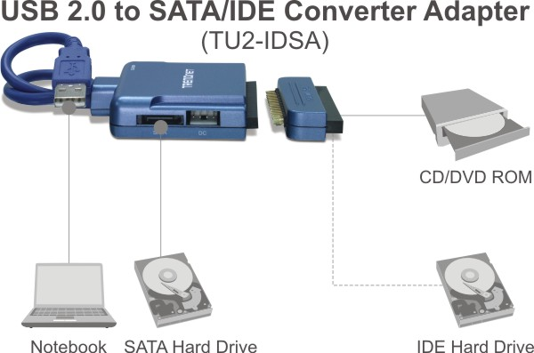  Serial ATA 1.0a (Serial ATA)  Ultra ATA 133 (Parallel ATA)
Supported OS | Windows 98SE/ME/2000/XP/2003 Server, Mac OS X
Connectors | SATA: 7-pin Signal Male  IDE: IDE 44-pin Female  IDE 2.5” to 3.5” Converter:  IDE 44-pin Male to 40-pin Female  USB: USB 2.0 Type A Male  DC: Mini 4-pin Power Connector  DC In: 2.1mm Power Plug
Data Rate | 1.5/12/480Mbps (USB)
Power Source | Input: AC 100~240V  Output: 12V DC, 2A
Weight | Adapter: 70g(2.5oz.)  Power Supply: 240g (8.5oz.)
Operating Temperature | 0° C~ 40° C (32° F~ 104° F)
Humidity | 85% (Non-Condensing)
Certification | FCC, CE
Package Contents System Requirement
- TU2-IDSA - Computer with an USB 1.1 or 2.0 Port
- Multi-Language Quick Installation Guide - CPU: 300 MHz or above
- Serial ATA Cable - Memory: 128MB or above
- Hard Drive Power Cable - Winodws 98SE/ME/2000/XP/2003 Server/Mac OS X
- 2.5” to 3.5” IDE Converter - IDE or SATA 1.0a device
- AC/DC Power Supply

