
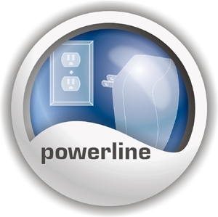
125Mbps 802.11g Wireless Powerline Access Point

The Wireless Powerline Access Point removes additional costs in network cabling by using existing power lines in your home or small office to network several wireless workstations. Secure file sharing, an Internet connection, or other network resources by using 56-bit DES for 14Mbps power line transmission and WPA security for 125Mbps wireless transmission.
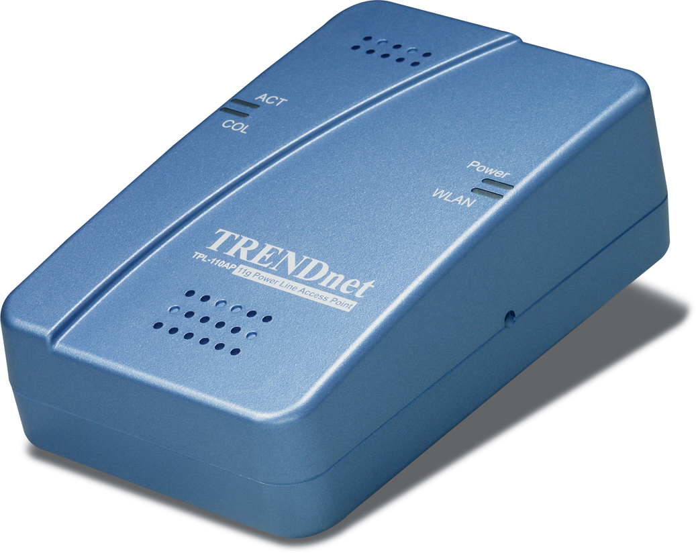

TPL-110AP
Features
- Wi-Fi Compliant with 802.11b/g Standards
- Up to 125Mbps High Speed over Wireless Connection (Afterburner Technology) (in Access Point Mode only)
- Up to 14Mbps High-Speed Data Transfer Rate over Power Lines
- Supports Access Point and Wireless Distribution System (WDS) Bridge/Repeater Modes
- Dynamic Data Rate Scaling at 54, 48, 36, 24, 18, 12, 9 and 6Mbps for 802.11g
- Dynamic Data Rate Scaling at 11, 5.5, 2 and 1Mbps for 802.11b
- Supports ESSID Enable/Disable Feature to Increase Security
- Supports 64/128-bit Wired Equivalent Privacy (WEP) , WPA and WPA-PSK
- Supports AP Isolation and MAC Address Filtering
- Compliant with Windows 95/98/NT/2000/XP/2003 Server, Linux and Mac OS
- Powerline Range of up to 300 meters (depends on the environment)
- Wireless Range of 30 ~ 100 meters Indoor (depends on the environment)
- Wireless Range of 50 ~ 300 meters Outdoor (depends on the environment)
- Connect to a Network using exiting Powerlines with Wall-Plugged Design
- 3-Year Warranty
Powerline Networking Solution
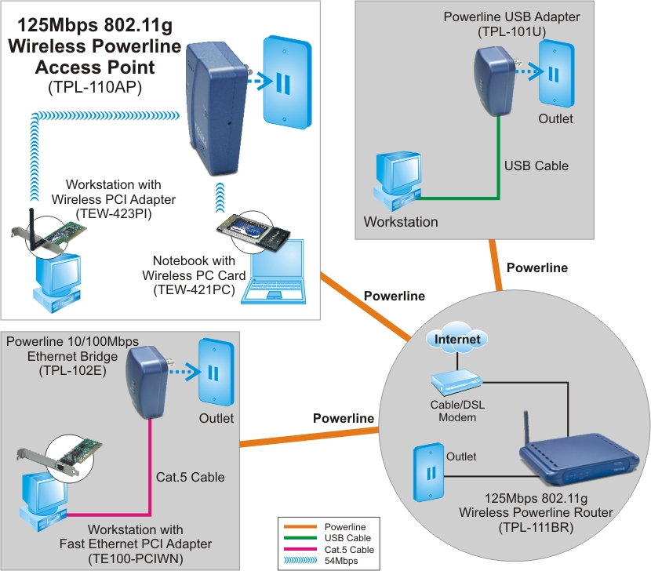
Specifications
Hardware
Standards | IEEE 802.11b (11Mbps), IEEE 802.11g (54Mbps)  IEEE 802.1x, HomePlug Powerline Alliance Industry Specifications V1.0
LED Indicators | Power, WLAN_TX/RX, HomePlug (Activity/Collision)
Network Protocols | TCP/IP, IPX, UDP
Power Source | Input: AC 120V, 0.1A, 50/60Hz
Dimensions (LxWxH) | 68 x 55 x 120 mm (2.7 x 2.2 x 4.7 inches)
Weight | 160g(5.64oz.)
Temperature | Operating: 0°~ 40°C (32°F~ 104°F)  Storage: -20°~ 65°C (-4°F~ 149°F)
Humidity | Operating: 10% ~ 85%  Storage: 5% ~ 90%
Certification | FCC, CE
Powerline
Interface | Power Prongs
Data Rate | Up to 14Mbps Transfer Rate
Nodes | Support up to 12 nodes per Network
Security | 56-bit DES Encryption
Wireless
Module Technique | 802.11b: DSSS  802.11g: OFDM
Frequency Range | 2.4 ~ 2.4835 GHz
Antenna | Built-in 2dBi Antenna
Data Rate  (auto fallback) | 802.11b: 11Mbps, 5.5Mbps, 2Mbps, and 1Mbps  802.11g: 54Mbps, 48Mbps, 36Mbps, 24Mbps, 18Mbps, 12Mbps, 9Mbps and 6Mbps
Security | 64/128-bit WEP  WPA and WPA-PSK (TKIP, AES, TIP+AES)  802.1x (Port-based Security with RADIUS)
Transmit Power | 13.5 ±1.5dBm (typical)
Receiving Sensitivity  (802.11a/b/g) | 11Mbps 10 ^{– 5} BER @ -80 dBm  54Mbps 10 ^{– 5} BER @ -65 dBm
Channels | Universal Domain Support (Channel 1~14)
Package Contents Related Products
- TPL-110AP - TPL-101U
- Quick Installation Guide - TPL-102E
- Utility CD-ROM - TPL-111BR

To order please call: 888-326-6061
3135 Kashiwa Street • Torrance, CA 90505 • (310) 891-1100 • Fax: (310) 891-1111

Sales: sales@trendware.com • Support: techsupport@trendware.com
Tech Support Hot Line: 1-310-626-6252

Official Site: www.TRENDNET.com

