
16-Port Rack Mount KVM Switch
TK-1601R 16-Port KVM Switch allows you to manage up to 16 PC's with just one keyboard, monitor, and mouse. Switch between multiple PC's with a simple press of a button! Eliminate the hassle of cable swapping and save money and space with TK-1601R. With its rack-mount kit and slim two unit height, it is perfect for mounting on EIA-19” rack in the Equipment Room and Computer Lab. With its Hot-Plug, Auto-Scan, Audible Feedback, and Hot-Key operations, the TK1601R is the perfect choice for managing multiple PCs.


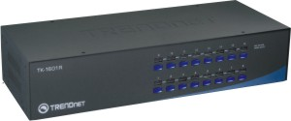

TK-1601R (Version V1.2R)

Features
- 16-Port PS/2 KVM Switch
- Supports Microsoft IntelliMouse, IntelliMouse Explorer, Logitech NetMouse, Optical Mouse and more
- Compliant with DOS, Windows 3.x/95/98(SE)/ME/NT/2000/XP/2003 Server, Unix, Linux, Netware and more
- High video quality, up to 1920 x 1440 VGA resolution
- Auto-Scan and LED display for monitored PCs
- Keyboard status restored when switching between PCs
- Beeping sound for port switching confirmation
- Hot-Key or push button switching
- Plug & Play and Hot-Pluggable
- Standard 19” (2U) rack mount design
- 2-Year Warranty
Specifications
Hardware
Management | 16 Computers
Supported OS | DOS, Windows 3.x/95/98(SE)/ME/NT/2000/XP/2003 Server  Netware, Unix, Linux and more
PC Port  (all female) | 16 x PS/2 Mouse 6-pin Mini Din  16 x PS/2 Keyboard 6-pin Mini Din  16 x VGA HDDB 15-pin
Console Port  (all female) | 1 x PS/2 Mouse 6-pin Mini Din  1 x PS/2 Keyboard 6-pin Mini Din  1 x VGA HDDB 15-pin
PC Selection | Hot-Key or Push Buttons
Auto-Scan Interval | 5-99 seconds
LED | On-line (Red), Select (Green)
Power Adapter | 9V DC 1A External Power Adapter (Optional)
Dimensions | 407 x 165 x 85mm (16.0 x 6.5 x 3.4in.)
Weight | 2.45kg (5.85lb)
Temperature | Operating: 0°C~40°C (32°F~104°F) Storage: -20°C~60°C (-4°F~140°F)
Humidity | 0%~80% (non-condensing)
Certification | CE, FCC

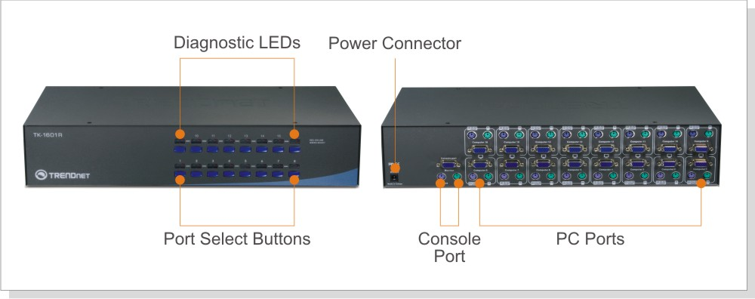

New Implements
- New Housing

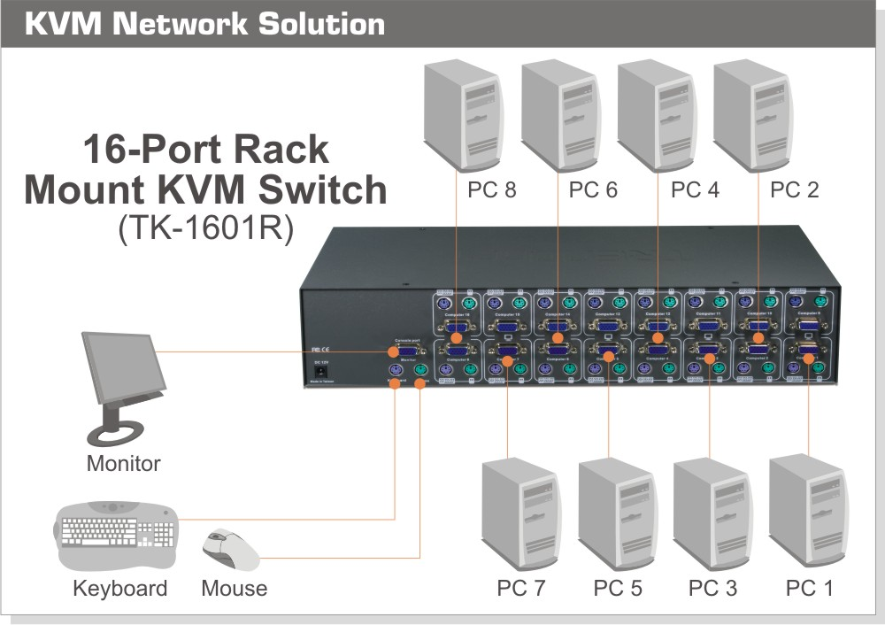

Package Contents Related Products
- TK-1601R - TK-801R
- Multi-Language Quick Installation Guide - TK-1602R
- Power Adapter (9V DC, 1A) - TK-1603R
- Rack Mount Kit
To order please call: 888-326-6061; Sales: sales@trendnet.com
Support: support@trendnet.com; Tech Support Hotline: 866-845-3673
Official Site: www.trendnet.com

