



19 dBi Outdoor
High-Gain Directional Antenna
TEW-AO19D Outdoor Directional Antenna provides long distance point-to-point connectivity for your wireless network. As an optional antenna for your IEEE 802.11b/g 2.4GHz wireless network equipment, you can install it outdoor for long distance point-to-point connections. Enjoy the benefits of wireless connectivity at greater distances and throughput throughout your outdoor wireless zone.
* This dBi gain does not factor cable loss. Performance estimations are for typical use; range will vary with site conditions.



TEW-AO19D version V1.0R

Features
- Compatible with 2.4GHz 802.11b/g wireless devices
- Weatherproof housing suitable for outdoor applications
- Adjustable mount for optimal orientation and performance
- Ideal for point-to-point bridge connections between buildings/zones
- Enhances wireless range and improves signal transmission and reception*
- Boosts standard antenna power from a meager 2dBi to a respectable 19dBi
- Easy-to-install wall and pole mounting
- 3-Year Warranty
*Due to the bisymmetrical nature of WiFi, the client segment may also require a high gain antenna.

Specifications

Hardware
Frequency range | 2.4 ~ 2.5GHz |  | Impedance |  | 50 Ohms
Gain | 19dBi |  | Connector |  | N-type Female
VSWR | 1.5:1 Max |  | Survival wind speed |  | 201.2km/ hr (125mi./hr)
Polarization | Linear, vertical |  | Lighting Protection |  | DC Ground
HPBW/ Horizontal | 18° |  | Radoms Material |  | ABS
HPBW/ Vertical | 18° |  | Dimension |  | 390 x 390 x 30mm  (15.4 x 15.4x 1.2in.)
Front to Back Ratio | 30dB |  | Weight |  | 950g (33.5oz.)
Power handling | 30W(cw) |  | Temperature |  | -40ºC ~ 80ºC (-40ºF ~ 176ºF)

* Note: For optimal results in extending your wireless range with wireless antenna installations, we recommend that you consult a professional installer for site survey, safety precautions, and proper installation.

Patterns

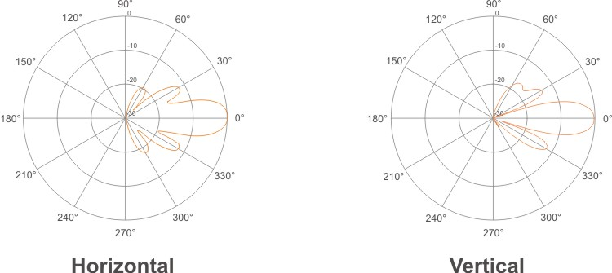

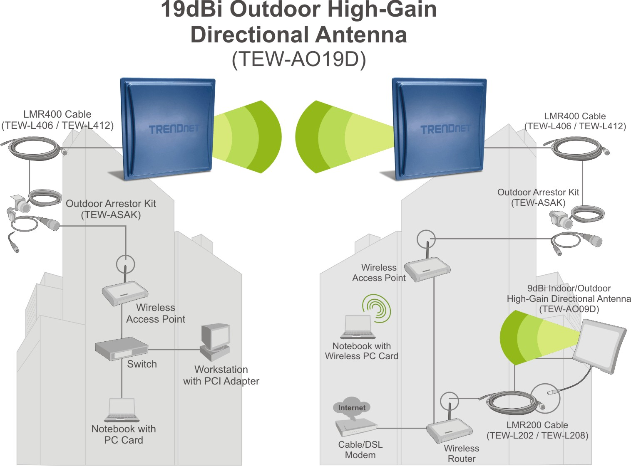

Antenna Solution with TEW-AO19D

Package Contents Related Products
- TEW-AO19D - TEW-AO09D
- Multi-Language Quick Installation Guide - TEW-AO14D
- Mounting Guide - TEW-AO08O
- Mounting Brackets - TEW-AO10O

To order please call: 888-326-6061; Sales: sales@trendnet.com
Support: support@trendnet.com; Tech Support Hotline: 866-845-3673
Official Site: www.trendnet.com

