

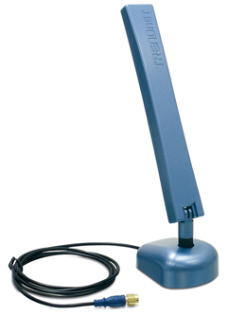
Dual-band 802.11a/g 7/5dBi
Indoor Omni Antenna with Mounting Base
TEW-AI75OB Omni Antenna provides more power and greater range for your wireless network. As an optional antenna for your IEEE 802.11b/g 2.4GHz or 802.11a 5GHz wireless network equipment, TEW-AI75OB will significantly improve signal strength and quality. TEW-AI75OB will work with any brand of devices with reverse SMA male connector!

* This dBi gain does not factor cable loss. Performance estimations are for typical use; range will vary with site conditions.

* This Figure does not include cable loss

TEW-AI75OB

Features

- Compatible with 2.4GHz 802.11b/g or 5GHz 802.11a wireless devices
- Detachable antenna base allows high gain antenna to be optionally connected to Wi-Fi device avoiding cable loss/attenuation
- Magnetic base allows convenient and optimal relocation to wall or any metallic surface
- Serves as an indoor omni relocation antenna.
- Enhances wireless coverage and improve signal transmission and reception
- Adjustable antenna face can tilt up to 180° and rotate up to 360° for optimal performance
- Easy-to-install wall and ceiling mount
- No configuration or installation software required
- 3-Year Warranty
Specifications

Hardware
Frequency range | 802.11a: 4.9 ~5.875GHz  802.11b/g: 2.4 ~ 2.5GHz |  | Impedance |  | 50 Ohms
Frequency range |  |  | Connector |  | Reverse SMA Female
Gain | 802.11a: 7dBi  802.11b/g: 5dBi |  | Cable Length |  | 100cm (3.3ft.)
Gain |  |  | Temperature |  | -10°C ~ 55°C (14°F ~ 131°F)
VSWR | 2.0:1 |  | Humidity |  | 95% at 25°C
Polarization | Linear, vertical |  | Weight |  | Antenna: 40g (1.4oz.)  Base: 82g (2.9oz.)
HPBW/ Horizontal | 360°
HPBW/ Vertical | 802.11a: 25°  802.11b/g: 35° |  | Dimension |  | Antenna:  217x28x14mm (8.5 x 1.1 x 0.55in.)  Base:  80x58x 28mm (3.15 x 2.28 x1.1in.)
Power handling | 2W (cw)



Radiation Patterns

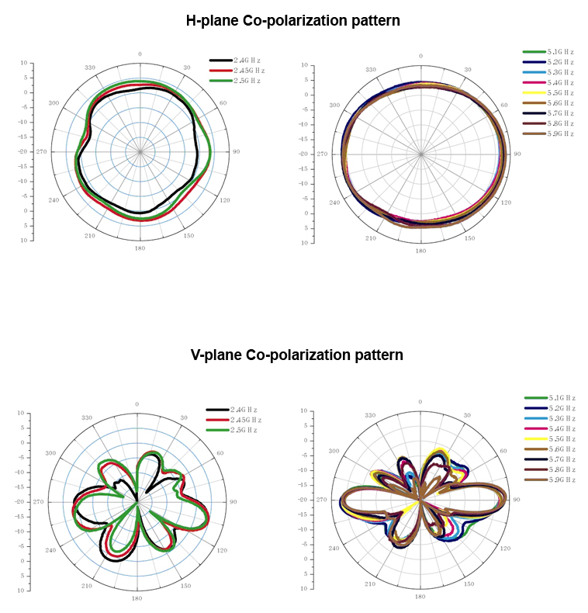



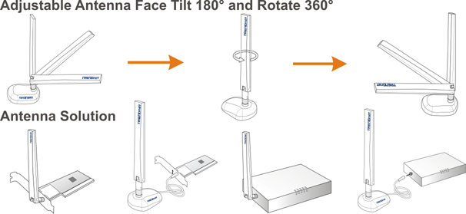
Antenna Solution with TEW-AI75OB

Package Content Related Product
- TEW-AI07OB - TEW-AI75O
- Mounting Kit - TEW-AI86D
- Multi-Language User’s Guide - TEW-AI86DB

To order please call: 888-326-6061; Sales: sales@trendnet.com
Support: support@trendnet.com; Tech Support Hotline: 888-777-1550
Official Site: www.trendnet.com

