

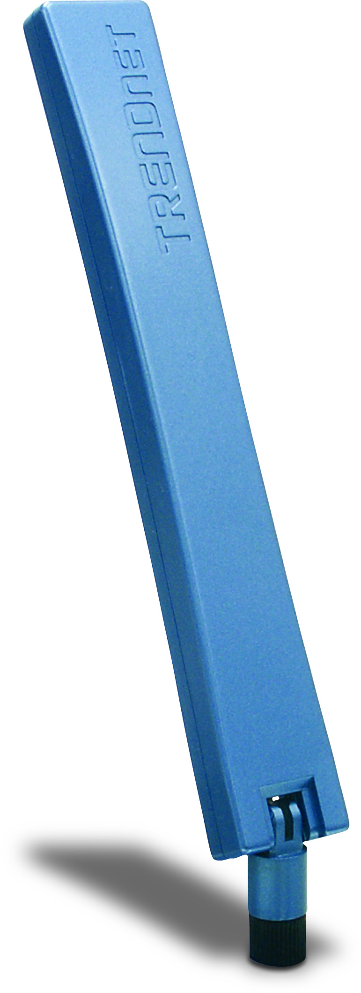
Dual-band 11a/g 7/5dBi Indoor Omni Antenna
TEW-AI75O Omni Antenna provides more power and greater range for your wireless network. As an optional antenna for your IEEE 802.11b/g 2.4GHz or 802.11a 5GHz wireless network equipment, TEW-AI75O will significantly improve signal strength and quality. TEW-AI75O will work with any brand of devices with reverse SMA male connector!
* This dBi gain does not factor cable loss. Performance estimations are for typical use; range will vary with site conditions.

TEW-AI75O
Features

- Compatible with 2.4GHz 802.11b/g or 5GHz 802.11a wireless devices.
- Works with any brand of wireless devices with reverse SMA male connector
- Serves as an indoor omni relocation antenna
- Enhances wireless coverage and improve signal transmission and reception
- Adjustable antenna face can tile up to 180° and rotate up to 360° for optimal performance.
- No configuration or installation software required
- 3-Year Warranty
Specifications

Hardware
Frequency Range | 802.11a: 4.9 ~ 5.875GHz  802.11b/g: 2.4 ~ 2.5GHz | Power Handling |  | 2W (cw)
Frequency Range | 802.11a: 4.9 ~ 5.875GHz  802.11b/g: 2.4 ~ 2.5GHz | Impedance |  | 50 Ohms
Gain | 802.11a:7dBi  802.11b/g:5dBi | Connector |  | Reverse SMA Female
Gain | 802.11a:7dBi  802.11b/g:5dBi | Dimension |  | 217 x 28 x14mm  (8.5 x 1.1 x 0.55in.)
VSWR | 2.0:1
Polarization | Linear, vertical | Weight |  | 41g (1.4oz.)
HPBW/ Horizontal | 360° | Temperature |  | -10°C ~ 55°C  (14°F ~ 131°F)
HPBW/ Vertical | 802.11a:25°  802.11b/g: 35°
HPBW/ Vertical | 802.11a:25°  802.11b/g: 35° | Humidity |  | 95% at 25°C



Radiation Patterns

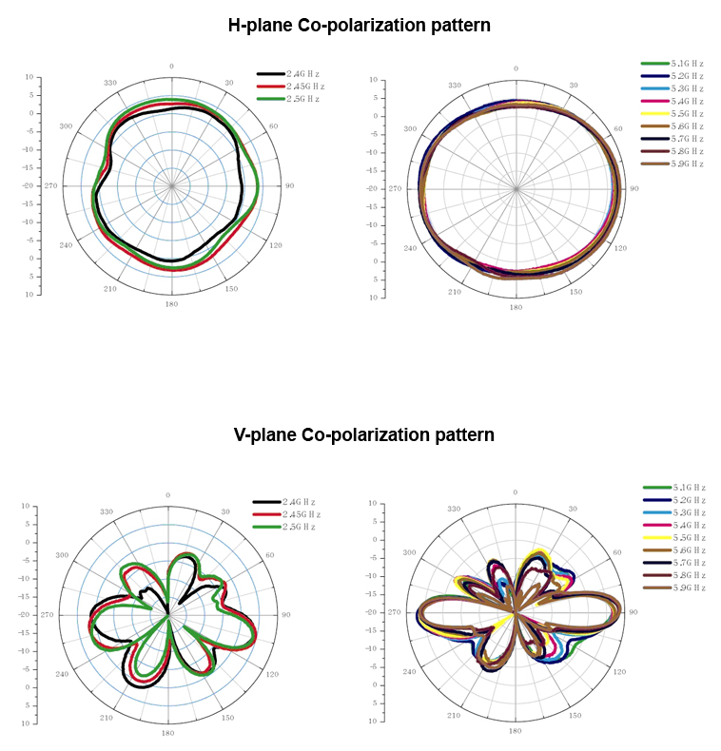



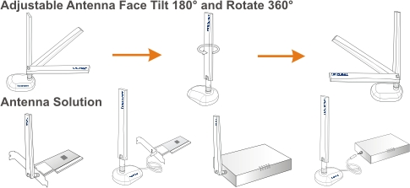

Antenna Solution with TEW-AI75O

Package Content Related Product
- TEW-AI75O - TEW-AI75OB
- Multi-Language User’s Guide - TEW-AI86D
- TEW-AI86DB

To order please call: 888-326-6061; Sales: sales@trendnet.com
Support: support@trendnet.com; Tech Support Hotline: 888-777-1550
Official Site: www.trendnet.com

