

108Mbps 802.11a+g Wireless Firewall Router

The TRENDnet TEW-511BRP Dual-Band 802.11a+g Wireless Router combines features from a wired router and wireless access point to create an all-in-one network solution for home or small office. Wireless clients equipped with the TEW-501PC 802.11a/g adapter can take advantage of Super AG technology by using frame bursts, fast frames, frame compression, and dynamic turbo to reach speeds up to 108Mbps. A built-in 4-port switch connects wired workstations to your network while the access point connects standard 802.11a/b/g wireless clients. TEW-511BRP is an ideal appliance for sharing Internet access and network resources. The TEW-511BRP’s firewall protects your network from hackers while WEP and WPA encryptions safeguard wireless transmission.
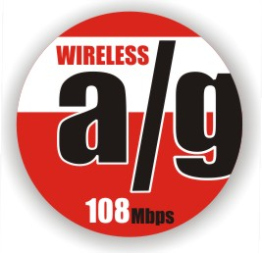
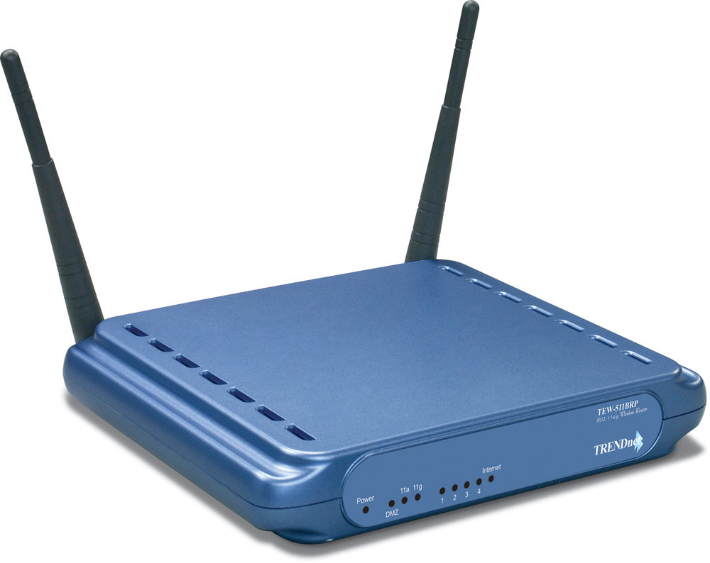

TEW-511BRP
Features
- Wi-Fi Compliant with IEEE 802.11a, 802.11g and IEEE 802.11b Standards
- Uses 5 GHz or 2.4 GHz Dual Band Design, which Complies with Worldwide Requirements
- 4 x 10/100Mbps Auto-MDIX LAN Port and 1 x 10/100Mbps WAN Port (Internet)
- Supports Cable/DSL Modems with Dynamic IP, Static IP, PPPoE, or PPTP Connection Types
- Supports Super G and Super AG and XR (eXtended Range) technology Data Rate up to 108Mbps (AP Mode Only)
- DHCP Server Feature Allocates up to 253 Client IP Addresses
- 64/128-bit WEP, WPA (Pre-Shared Key or RADIUS) supports TKIP or AES Algorithm
- Supports MAC Address, IP and Protocol Filters
- Firewall features Network Address Translation (NAT), and Stateful Packet Inspection (SPI) protects against Dos attacks
- Traffic Control with Virtual Server and DMZ
- Provides Additional Security of Enable/Disable SSID, Password Protection
- Supports Static/Dynamic Routing and Dynamic DNS
- Supports Multiple and Concurrent IPSec, L2TP and PPTP VPN Pass-Through Sessions
- Flash Memory for Firmware Upgrade, Save/Restore Settings, and Traffic Log
- Easy Management via Web Browser (HTTP) and Remote Management
- Compliant with Windows 95/98/NT/2000/XP/2003 Server, Linux and Mac OS
- Range of 30 ~ 100 meters Indoor(depends on the environment)
- Range of 50 ~ 300 meters Outdoor(depends on the environment)
- 3-Year Warranty
Wireless A+G Networking Solution

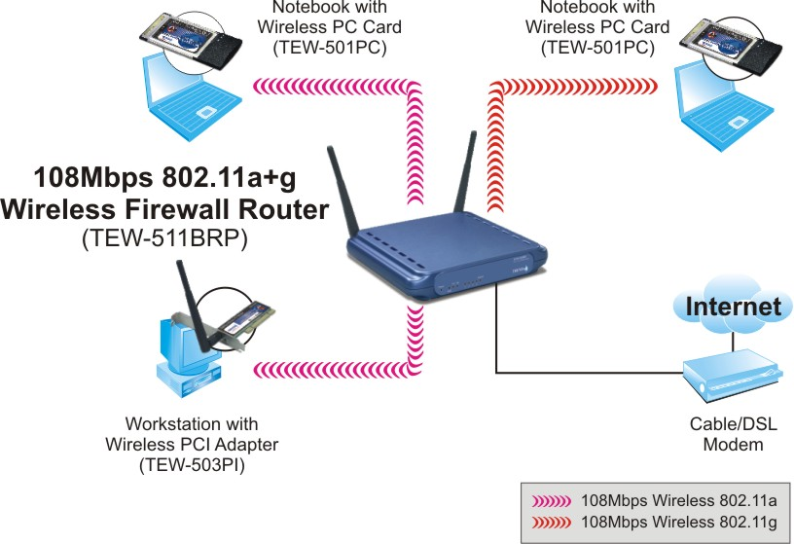
* Due to European Wireless Regulations, Super A mode is not supported in the EU version.
Specification

Hardware
Standards | Wired: IEEE 802.3 (10Base-T), IEEE 802.3u (100Base-TX)  Wireless: IEEE 802.11a (54Mbps), 802.11b (11Mbps), IEEE 802.11g (54Mbps)
WAN | 1 x 10/100Mbps Auto-MDIX Port (Internet)
LAN | 4 x 10/100Mbps Auto-MDIX Port
Connection Type | Dynamic IP, Static (Fixed) IP, PPPoE, PPTP
Advance Features | DHCP Client/Server, SPI, NAT, PPPoE Client, DNS Proxy/Relay, Dynamic DNS  DMZ Hosting, VPN Pass-Through (IPSec, PPTP, L2TP), NTP  UPnP, NAT Traversal
Protocol Support | TCP/IP, NetBEUI, IPX/SPX
LED Indicator | Power, DMZ, 11a, 11g, LAN, Internet
Power Adapter | 5V DC, 2.5A External Power Adapter
Dimension (L x W x H) | 198 x 160 x 33 mm (7.8 x 6.3 x 1.2inches)
Weight | 0.7kg (1.54 lbs)
Temperature | Operation: 0°~ 40°C (32°F~ 104°F) Storage: -20°~ 70°C (-4°F~ 158°F)
Humidity | Max. 90% (Non-Condensing)
Certification | FCC & CE

Wireless
Module Technique | 802.11b: CCK (11 and 5.5Mbps), DQPSK (2Mbps), DBPSK (1Mbps)  802.11a/g: OFDM with BPSK, QPSK and 16/64-QAM Sub-Carrier Modulations
Frequency | 802.11a: UNI-Band 5.15 ~ 5.825 GHz (subject to local regulations)  802.11b/g: ISM-Band 2.412 ~ 2.4835 GHz
Antenna | 802.11a: 4dBi (Peak Gain); 802.11b/g: 2dBi (Peak Gain)  2 x Dual Band Diversity Detachable Antenna (Female Reverse SMA Connector)
Media Access Protocol | CSMA/CA with ACK
Data Rate | 802.11b: 11Mbps, 5.5Mbps, 2Mbps, and 1Mbps  802.11g: 54Mbps, 48Mbps, 36Mbps, 24Mbps, 18Mbps, 12Mbps, 9Mbps and 6Mbps  Super AG: 108Mbps
Security | 64/128-bit WEP & WPA  802.1X (EAP-MD5/TLS/TTLS)  SSID Broadcast Control, MAC Filter, IP Filter, Content Filter  Time-of-Day ACL
Transmit Power | 802.11a: 16dBm (max) @ 16QAM R3/4  802.11b: 18dBm (typical)  802.11g: 16dBm (typical)
Receiving Sensitivity  (802.11a/g) | 108Mbps 10 ^{– 5} BER @ -69 dBm (Turbo Mode)  54Mbps 10 ^{– 5} BER @ -72 dBm ; 48Mbps 10 ^{– 5} BER @ -75 dBm  36Mbps 10 ^{– 5} BER @ -82 dBm ; 24Mbps 10 ^{– 5} BER @ -85 dBm  18Mbps 10 ^{– 5} BER @ -88 dBm ; 12Mbps 10 ^{– 5} BER @ -89 dBm  9Mbps 10 ^{– 5} BER @ -90 dBm ; 6Mbps 10 ^{– 5} BER @ -91 dBm
Channels | 11a: Subject to Local Regulations  11b/g: 1~ 11 (US), 1~13 (EU)
Package Contents Related Products
- TEW-511BRP - TEW-501PC
- Multi-Language QIG - TEW-503PI
- CD-ROM (User’s Guide) - TEW-504UB
- Power Adapter (5V DC, 2.5A) - TEW-510APB
- RJ-45 Cable (1.5m)

To order please call: 888-326-6061
3135 Kashiwa Street • Torrance, CA 90505 • (310) 891-1100 • Fax: (310) 891-1111
Sales: sales@trendware.com • Support: techsupport@trendware.com
www.TRENDnet.com

