

Cable/DSL 802.11b 11Mbps Wireless Router
TRENDnet’s TEW-231BRP 11Mbps 802.11b Wireless Router delivers wireless internet access for your home or small office. It includes a Wireless Access Point, Internet Router, and 4-Port 10/100Mbps Switch all in one. Now you can share a Cable or DSL connection with multiple wired or wireless users! Protect your network from outside intruders with a Network Address Translation (NAT) firewall and 128-bit WEP encryption for wireless data transfer. Also, limit access to undesirable content by controlling web access via URL or Time/Date. Setting up the unit is effortless with a Web Browser Configuration tool and UPnP support. Cut the wires and move freely with TRENDnet’s 802.11b wireless products.

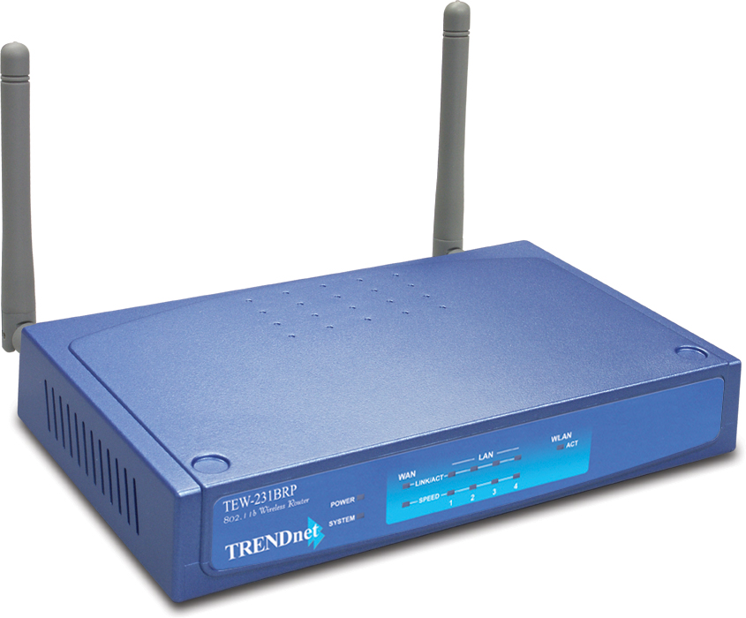

TEW-231BRP

FEATURES
- IEEE 802.11b Wireless, IEEE 802.3 Fast Ethernet Standards Compliant
- 4-Port 10/100Mbps Auto-Sensing, Auto-MDIX Switch for Sharing Internet Connection for up to
253 Users
- 1-Port 10/100Mbps Auto-MDIX WAN Port
- Dynamic Data Rate Shift at 11, 5.5, 2 and 1Mbps
- Supports 64/128-bit Wired Equivalent Privacy (WEP)
- Supports Cable/xDSL Modem (Dynamic IP, Static IP, PPPoE, PPTP)
- Supports NAT Firewall Protection
- Supports Virtual Server (10 entry) and DMZ (1 entry)
- Internet Access with IP Address (10 entry). MAC Address and Special Application Filter.
- Supports UPnP (Universal Plug & Play)
- Easy Configuration Using Web Browser
- Flash Memory for Firmware Upgrade
- Dual Detachable 2dBi Antennas with Female Reverse SMA Connetors
- Distance Coverage 50 to 100 meters indoor, 100 to 500 meters outdoor
- 3-Year Warranty

TREND SPEC’S

Standards: IEEE 802.11b Wireless LAN, IEEE 802.3, IEEE 802.3u and
ANSI/IEEE 802.3 Auto-Negotiation
Protocols: DHCP (Client and Server), TCP/IP, NAT, PPPoE, PPTP, SNTP and HTTP
Module Technique: Direct Sequence Spread Spectrum (DSSS), CCK, DQPSK, DBPSK
Channel: 1~11 Channel
Wireless Data Rate: 11Mbps, 5.5Mbps, 2Mbps, and 1Mbps
Frequency Range: 2.4 ~ 2.497 GHz
Security: 64/128-bit WEP Encryption
Antenna: 2 x Detachable 2dBi Antenna with Reverse SMA connector
Output Power: 13 dBm (max.)
Receiving Sensitivity: 11Mbps: 10-5 BER @ -83 dBm (min.).
2Mbps: 10-5BER @ -84 dBm (min.)
Local Port: 4 UTP/STP 10/100Mbps Auto-MDIX ports
WAN Port: 1 UTP/STP 10/100Mbps Auto-MDIX port
Throughput: 83Mbps (LAN to WAN), 5.05Mbps (LAN to WLAN)
Flash Memory/RAM: 8M/8M
LED Indicators: Unit: Power, System
LAN Port: LINK/ACT, Speed
WAN Port: LINK/ACT, Speed
WLAN: ACT
Power: 7V DC, 1A External Power Adapter
Dimensions: 171 x 100 x 34 mm (6.73 x 3.93 x 1.3 inch), without Antenna
Weight: appr. 272g. ( 9.6oz.)
Temperature: Operating: 0°~ 55°C (32°F~131°F)
Storage: -25° ~ 70°C (-13°F~158°F)
Humidity: 10% ~ 95% RH (non-condensing)
Certification: FCC, CE

TOP REASONS THE TEW-231BRP IS THE LASTING TREND

Easy Integration: Broadband Router, Access Point, and 4-port 10/100Mbps Switch all
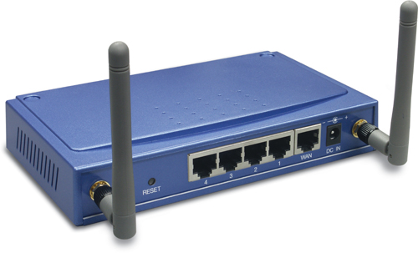
in one unit, share your broadband Internet connection with 802.11b wireless and wired Ethernet Clients.
Cost-Effectiveness: Saves on-line charges and spaces.
Security: NAT firewall protection keeps hackers out. 64/128-bit WEP and MAC Address
Access Control protects AP from unwanted wireless clients.
Performance: Experience the high speed Internet access while reducing network traffic.

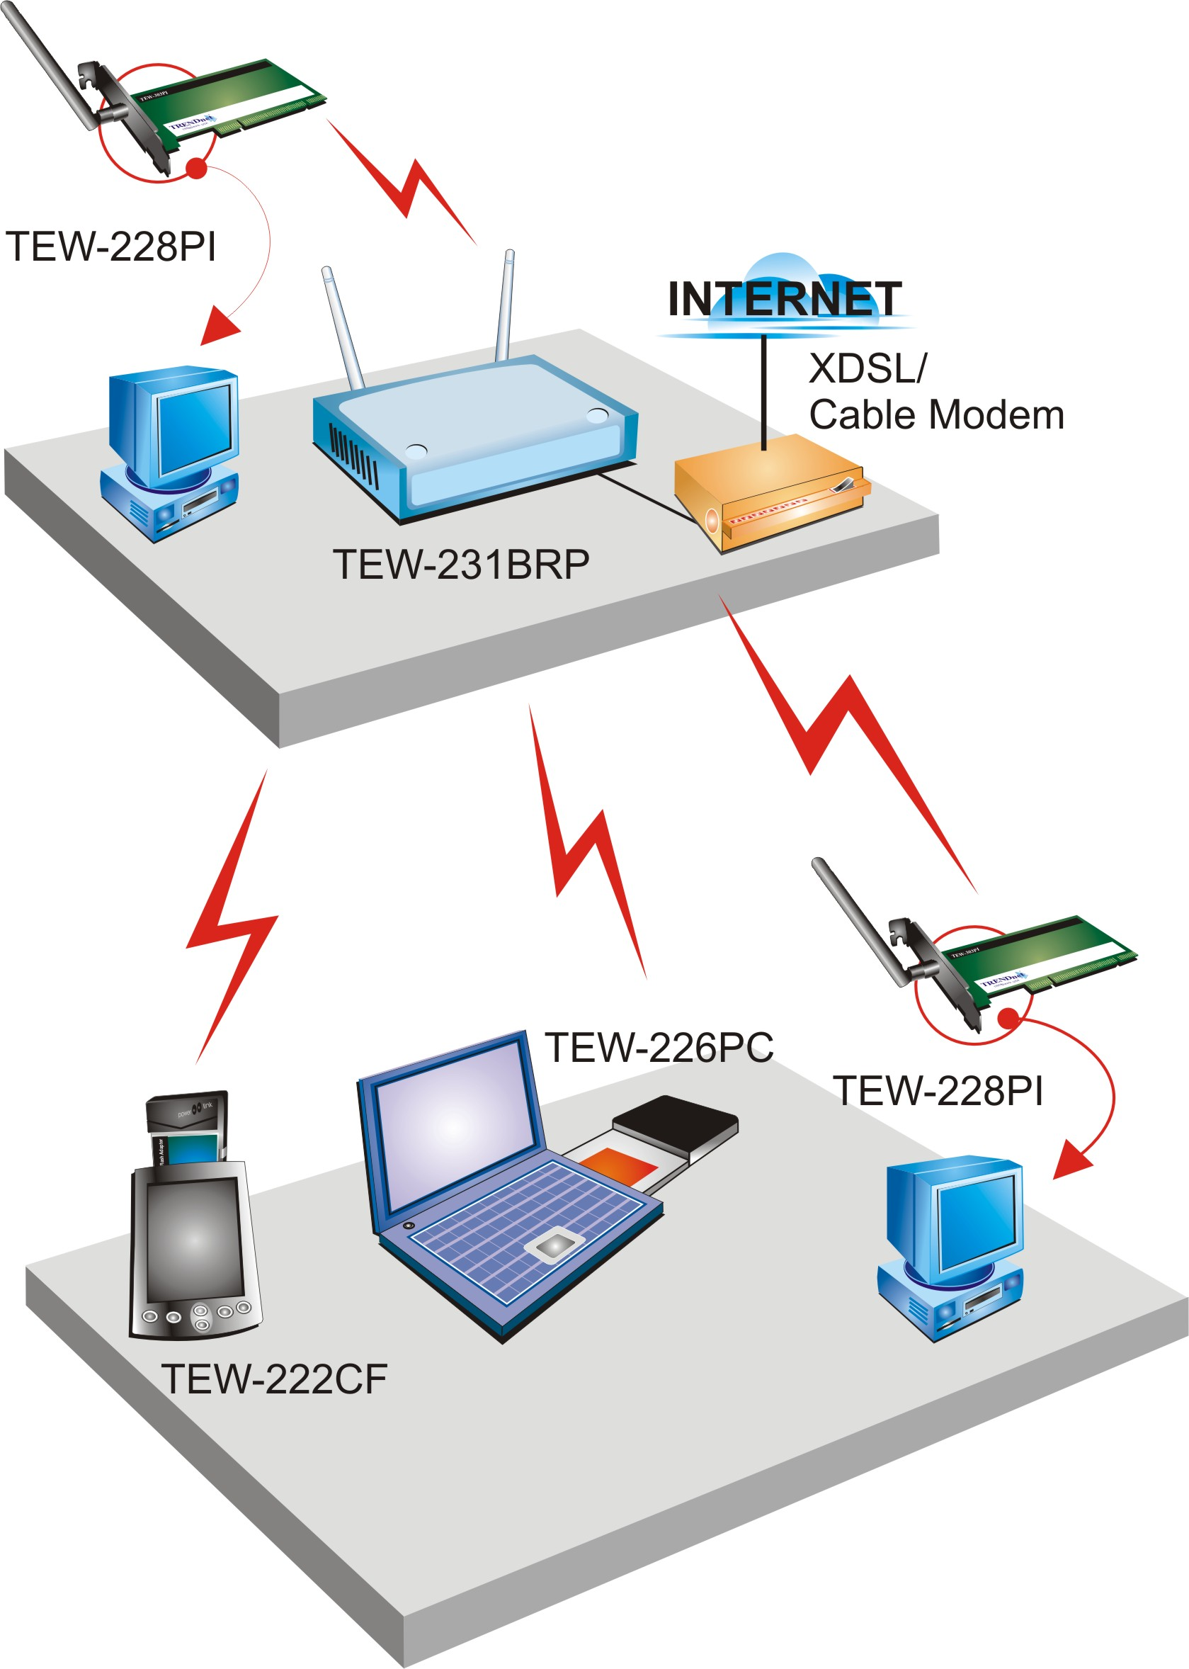
Network Solution for
TEW-231BRP

Product Information
TEW-231BRP Cable/DSL 802.11b 11Mbps Wireless Router
TEW-226PC 11Mbps 802.11b Wireless PC Card
TEW-228PI 11Mbps 802.11b Wireless PCI Adapter
TEW-222CF 11Mbps 802.11b Compact Flash Adapter


To order please call: 888-326-6061
3135 Kashiwa Street • Torrance, CA 90505 • (310) 891-1100 • Fax: (310) 891-1111
Sales: sales@trendware.com • Support: techsupport@trendware.com
www.TRENDNET.com

