
10/100/1000Mbps Gigabit Network Kit

TRENDnet's TEG-SK2, a 10/100/1000Mbps Copper Gigabit Ethernet Network Kit, is a complete solution for connecting two personal computers to share drives, files, printers, and play network games. This network kit comes with two 32-bit 10/100/1000Mbps Copper Gigabit PCI adapters (TEG-PCITXR), one 6 meters (20 feet) Cat.5e RJ-45 cable, and an easy-to-follow installation guide. You can network your computers in just minutes. As your network grows, simply add TRENDnet's Gigabit Switch to accommodate additional workstations. Designed especially for homes and small offices, this reliable network kit provides 2000Mbps bandwidth with network expandability in the future.

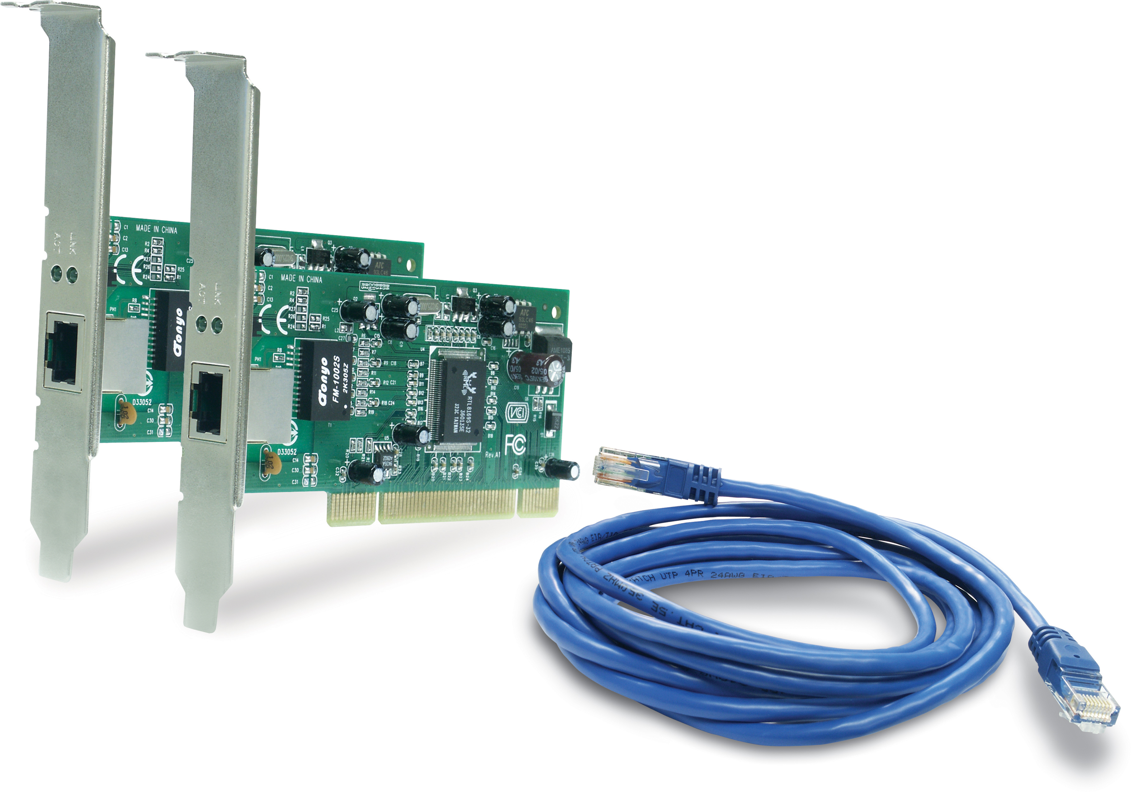

TEG-SK2

FEATURES
- 2 x TEG-PCITXR - 10/100/1000Mbps 32-Bit Copper Gigabit PCI Adapters
- IEEE 802.3, 802.3u and 802.3ab compliant
- Support 32-Bit PCI Local Bus Master high-speed operation of Rev. 2.2 specification
- One RJ-45 Connector with connection speed Auto-Sense and Auto-MDIX media type detection
- Supports Full-Duplex mode and doubles the bandwidth to 20/200/2000Mbps
- Supports Win98/ME/NT4/2000/XP, Netware Server (5.x,/6.x) and Linux Kernel (2.2.x/2.4.x)
- Built-in FIFO (8K/64K) buffer reduces overhead of memory transfers
- Supports Wake-on-LAN for remote wake up
- IEEE802.1Q Virtual LAN (VLAN) tagging support
- Plug and Play Installation
- 5-Year Warranty
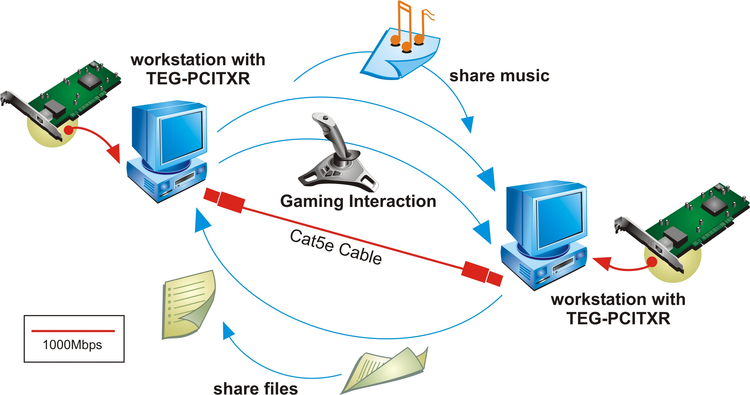

Network Solution for TEG-SK2

To order please call: 888-326-6061
3135 Kashiwa Street • Torrance, CA 90505 • (310) 891-1100 • Fax: (310) 891-1111
Sales: sales@trendware.com • Support: techsupport@trendware.com

