
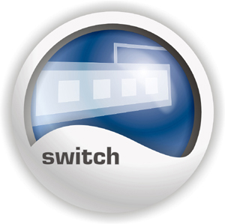

32-Port 10/100Mbps Fast Ethernet Switch
TRENDnet’s TE100-S32plus is a high performance, auto-sensing 32-port rack-mountable Fast Ethernet Switch. It is designed to eliminate unnecessary traffic and relieve congestion on critical network paths. It automatically negotiates between 10/100Mbps network speed and half/full duplex modes.
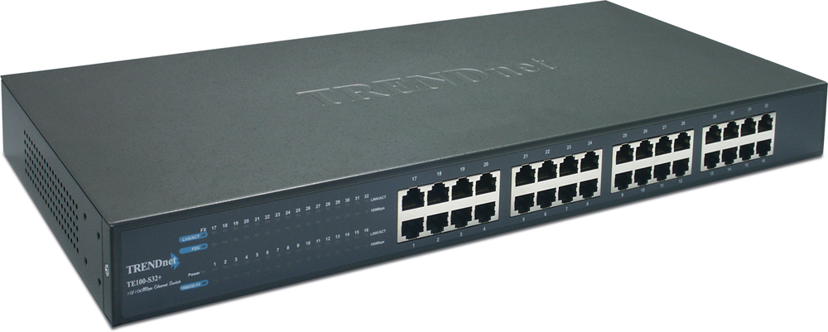

TE100-S32plus

Features
- 32 x 10/100Mbps Auto Negotiation and Auto-MIDX ports
- 1 Module Bay for Optional 100Base-FX SC Type Connector Fiber Module
- Full/Half Duplex Transfer Mode for Each Port
- Store and Forward Switching Method
- Integrate Address Look-Up Engine, Supports 4K Absolute MAC Address
- Supports 1M Bytes RAM for Data Buffering
- Extensive Front Panel Diagnostic LEDs
- Broadcast Storm Protection
- IEEE 802.3x Flow Control for Full-Duplex Mode
- Backpressure Flow Control for Half-Duplex Mode
- Standard 19” Rack-Mount Design
- 5-Year Warranty
Specifications
Hardware
Standards | IEEE 802.3 10Base-T  IEEE 802.3μ 100Base-TX  ANSI/IEEE 802.3 Auto-Negotiation
Protocol | CSMA/CD
Topology | Star
Connectors | 32 x10/100Mbps Auto-MDIX RJ45 Ports  1 x 100Base-FX Fiber Module Slot for Optional Fiber Adapter (TE100-SFXM)
Cabling | Cat. 3,4,5 UTP/STP for 10Base-T  Cat. 5 UTP/STP for 100Base-TX  62.5/125u Multimode Fiber/SC Type Connector for 100Base-FX
Data Transfer Rate | 10Mbps: 10/20Mbps (Half/Full Duplex)  100Mbps: 100/200Mbps (Half/Full Duplex)
Data Range | 10Mbps: max 100 meters  100Mbps: max 100 meters  100Base-FX: max 2KM
Data RAM Buffers | 1MB per device
Filtering Address Table | 4K Entries Per Device
Diagnostic LEDs | Power, 10/100Mbps Link/Activity, Collision/Full Duplex, FX
Power | 100 ~ 240VAC 50/60Hz, Internal Universal Switching Power
Power Consumption | 40 Watts (Max)
Dimensions (W x H x D) | 440mm x 200mm x 44mm (17.3” x 7.9” x 1.73”)
Weights | 3.0 Kg (6.6 lb)
Temperature | Operating: 0°C ~ 40°C (32°F ~ 104°F)  Storage: -10°C to 70°C (14°F to 158°F)
Humidity | Operating: 10 % ~ 90 % (non-condensing)  Storage: 5 % ~ 90 %(non-condensing)
Certifications | FCC, CE



TOP REASONS THE TE100-S32plus IS A LASTING TREND

Integration Friendly | Easily upgrade to Fast Ethernet without changing switch
Economical  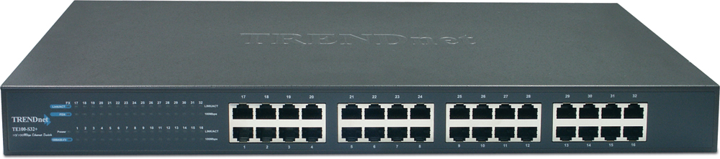 | Provides 10/100Mbps of Fast Ethernet in the same unit
Flexible  Front View | All Ports automatically negotiate 10/100 network speed, half/full modes, and Auto-MDIX connector type
Performance | Supports store and forward switching architecture with non-blocking full wire-speed performance
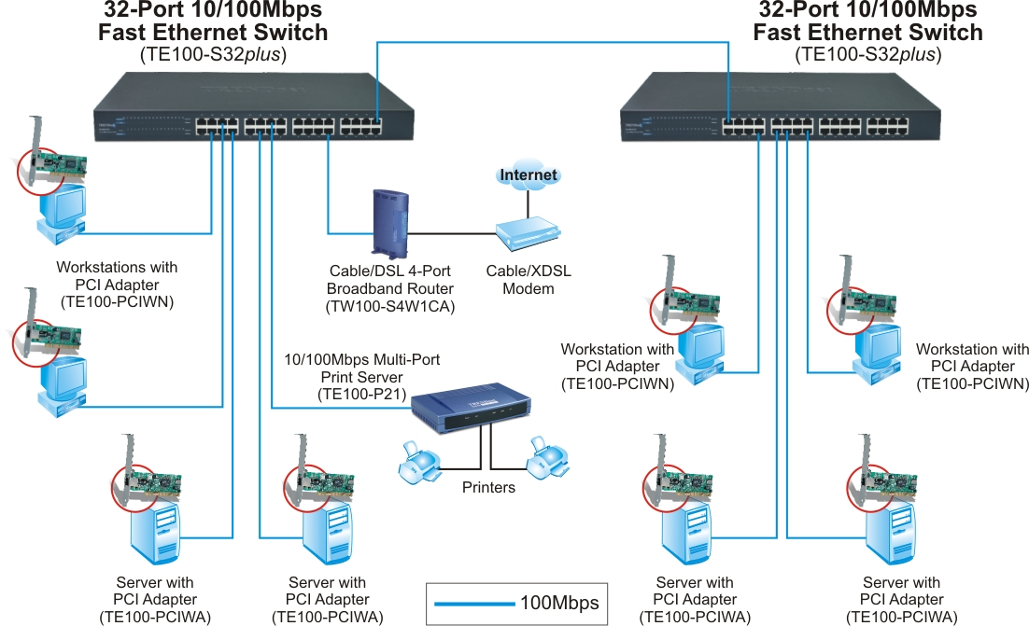

Network Solution for TE100-S32plus

Package Contents Related Product
- TE100-S32plus - TE100-S16
- Multi-Language User’s Guide - TE100-S24
- Power Cord - TE100-SFXM
- Rack Mount Kit
To order please call: 888-326-6061
3135 Kashiwa Street • Torrance, CA 90505 • (310) 891-1100 • Fax: (310) 891-1111

Sales: sales@trendware.com • Support: techsupport@trendware.com
Tech Support Hot Line: (310)626-6252

Official Site: www.TRENDNET.com

