

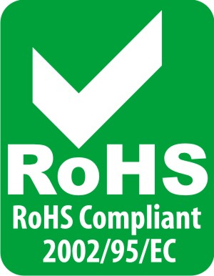

24-Port 10/100Mbps Fast Ethernet Switch

This 24-Port 10/100 switch is a high performance auto-sensing switch that automatically negotiates between 10Base-T and 100Base-TX network speeds. All ports support full/half-duplex mode for maximum network performance. Designed and built to increase network bandwidth, this 24-Port 10/100 switch is the best solution for both corporate and small business network environments.

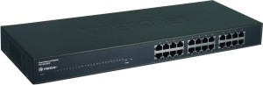

TE100-S24 (Version B1.1R)

Features
- 24 10/100Mbps Auto-Negotiation, Auto-MEDIX Fast Ethernet RJ-45 ports
- Compliant with IEEE 802.3 / IEEE 802.3u standards
- Provides 2.5Mbits RAM for Data Buffering
- Integrated 8K MAC address entries
- Compliant with Windows, Linux, and Mac Operating Systems
- IEEE 802.3x Flow Control
Operates and maximizes packet filtering
- Store-and-Forward Switching method
- Non-blocking Architecture
- Max 4.8Gbps Switching Capacity
- Plug & Play
- Standard 19” (1U) rack mount design
- 5-Years Warranty
Specifications
Hardware
Standard | IEEE 802.3 10Base-T  IEEE 802.3u 100Base-TX
Interface | 16 10/100Mbps Auto-MDIX RJ-45 Ports
Network Media | Ethernet: UTP/STP Cat. 3,4,5  Fast Ethernet: UTP/STP Cat. 5, 5e, 6
Switch Fabric | 4.8Gbps Forwarding Capacity
Data Transfer Rate | Ethernet: 10/20Mbps (Half/Full Duplex)  Fast Ethernet: 100/200Mbps (Half/Full Duplex)
Data RAM Buffering | 2.5Mbits per device
MAC Table | 8K Entries per device
Protocol | CSMA/CD
Transmission Method | Store-and-Forward
Power | 100-240VAC, 50/60H, Internal Power Supply
Power Consumption | 10 Watts (Max)
Diagnostic LED | Power, Link/ACT, 100Mbps
Weight | 1.86kg (4.1lb)
Dimensions (W x H x D) | 440 x 140 x 44mm (17.3 x 5.51 x 1.73 in.)
Temperature | Operating: 0°C ~ 40°C (32°F ~ 104°F)  Storage: -10°C to 70°C (14°F to 158°F)
Humidity | Operating: 10 % ~ 90 % (non-condensing)  Storage: 5 % ~ 90 %(non-condensing)
Certification | FCC, CE

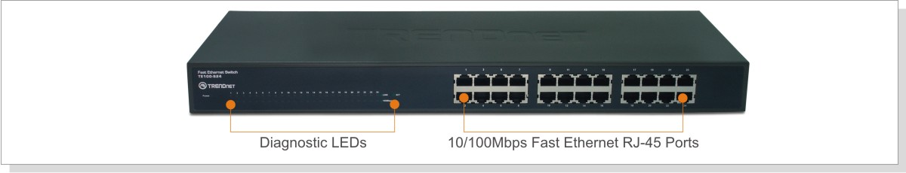

New Implements
- New TRENDnet Housing
- New Front Panel Design

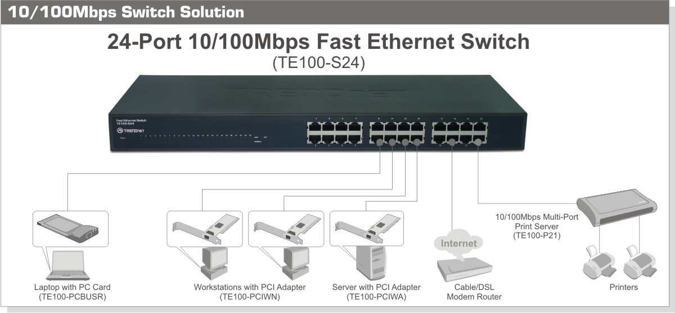

Package Contents Related Product
- TE100-S24 - TE100-S16
- Multi-Language Quick Installation Guide - TE100-S16Eplus
- Power Cord - TE100-S32plus
- Rack Mount Kit

To order please call: 1-888-326-6061 (USA)

Sales: sales@trendnet.com • Support: support@trendnet.com
www.trendnet.com

