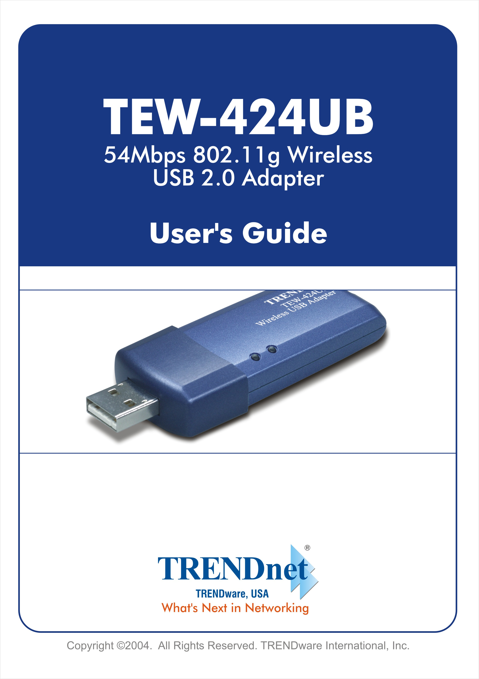
Table of Contents
About This Guide 3

1. Introduction 4
Package Contents 5
System Requirements 6
General Features 6
Product View 7

2. Hardware Installation 8
Installing the USB Adapter 8
Networking Application 10

3. Using The Utility 11
Auto-Run Installation 11
Installing the Configuration Utility 12
Changing the Control Setting 15
Using the Configuration Utility 17

4. Product Specifications 27

About This Guide
This manual provides instructions and illustrations on how to use your IEEE 802.11b/g Wireless USB2.0 Adapter:
- Chapter 1, Introduction, provides the general information of the adapter.
- Chapter 2, Hardware Installation, describes the hardware installation procedure and the application of the adapter.
- Chapter 3, Using the Utilities, helps you to install and use the software.
- Chapter 4, Product Specification.

Please note that the illustrations or setting values in this manual are FOR YOUR REFERENCE ONLY. The actual settings and values depend on your system and network. If you are not sure about the respective information, please ask your network administrator or MIS staff for help.

1

Introduction
Congratulations on purchasing the IEEE 802.11b/g Wireless USB2.0 Adapter, a device that based on 802.11g technology and compatible for interoperability with existing 802.11b devices. It provides a data rate that can be up to 54 Mbps* and auto-negotiated to 48, 36, 24, 18, 12, 9, 6Mbps (IEEE 802.11g), or 11, 5.5, 2, 1Mbps (IEEE 802.11b). For your networking security, the communications through this adapter are protected by up to 256-bit WEP encryption, so your data stays secure.
This hot-plug USB-interface adapter comes with a user-friendly software utility and driver for the most popular Microsoft® Windows operating system, allowing you to run the configuration utility and uses easily. This adapter can be integrated into your network with either Ad-hoc mode (without an access point or router) or Infrastructure mode (an access point or router is required). Using this adapter, you can share files, printers, and high-speed Internet over your existing wireless network.

* A theoretical maximum value of the adapter. Actual throughput may vary depending on the distance between wireless adapters, the configuration of your working environment, or the capabilities or limitations of your computer systems.

Package Contents
Unpack the package and check all the items carefully, and be certain that you have:
- One 802.11b/g Wireless USB2.0 Adapter.
- One Quick Installation Guide.
- One Installation CD-ROM containing the driver, utility and User’s Guide.
- One USB Cable.

If any item contained is damaged or missing, please contact your local dealer immediately. Also, keep the box and packing materials in case you need to ship the unit in the future.

* Before installing the adapter, please confirm that the USB port to be connected on the target device is compliant with USB 2.0 standard; otherwise, the throughput will be changed.

System Requirements
- A computer or laptop with an available USB port.
- Microsoft Windows® 98SE/ME/2000/XP.
- At least 32MB of memory and a 300MHz processor.
- Properly installed and working USB Controller in your system.

General Features
- Compatible with IEEE 802.11g for 2.4GHz wireless networking environment, and backwards compatible with 802.11b standard.
- Plug-and-Play installation.
- Works with all existing network infrastructure.
- Compatible with Wi-Fi wireless products and services.
- Supports 64, 128 and 256-bit WEP shared-key encryption.
- Freedom to roam while staying connected.
- Up to 54Mbps high-speed transfer rate.
- Support internal antenna for better sensitivity.
- Easy-to-install and user-friendly configuration utility.

Product View
This section describes the externally visible features of the adapter.

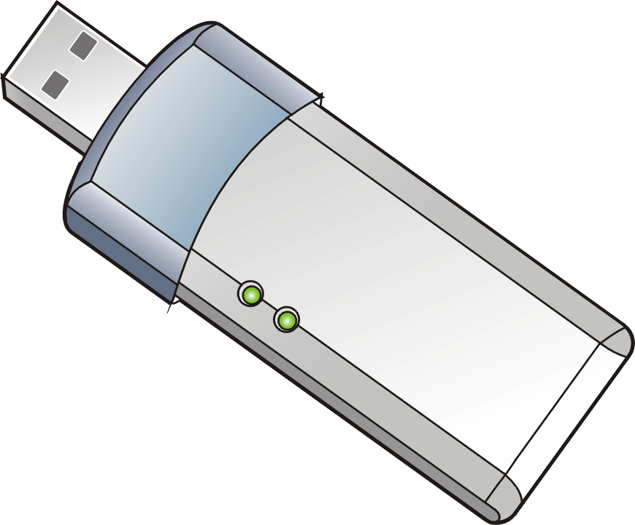
USB connector
LEDs
Link
ACT
Wireless USB2.0 Adapter (with cap opened)

LEDs | Description
Link  (Green) | Steady light to confirm the adapter is connected to the wireless network.
ACT  (Green) | Blinking light to confirm the adapter is receiving/ transmitting data from/to the wireless network.

2

Hardware Installation

Installing the USB Adapter
To install the USB adapter, simply plug it into an available USB port on your computer.

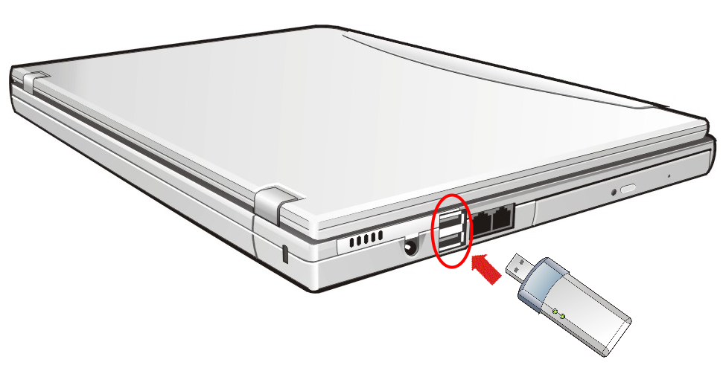
USB Port

The USB adapter supports hot-plug function, so you can remove it under Windows operating system without shutting down the system. To remove the USB adapter, gently pull the adapter out from the port.

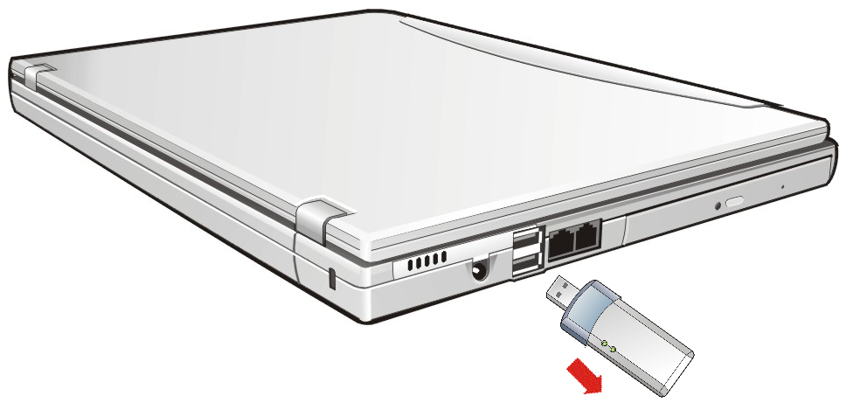

- Caution: Please do not connect the Wireless USB Adapter until the TEW-424UB Utility Software is installed.

NOTE: DO NOT remove the USB adapter while transferring data (the ACT LED is flashing). Please close the communication programs or stop the task before removing it.

Networking Application
The following diagram explains the application of your USB adapter in your wireless network.
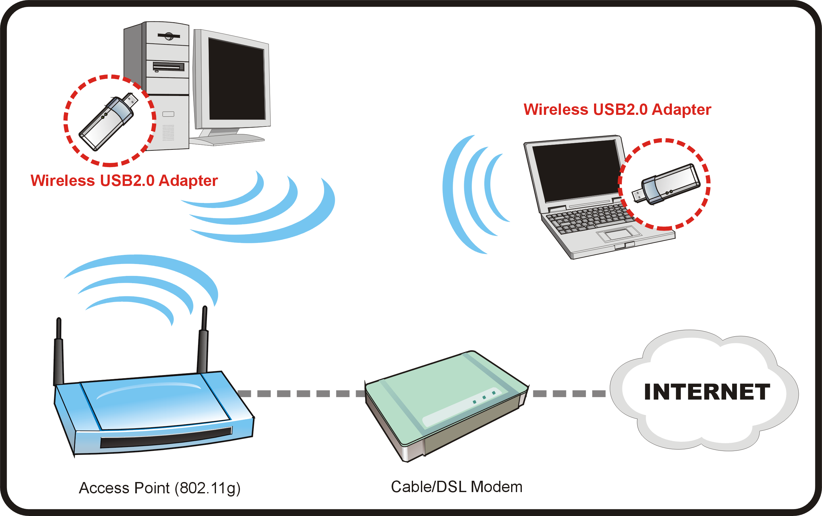

To build a wireless network at home (as shown above), you may need the followings:
- A broadband Internet access (a Cable/DSL subscriber line) from your ISP.
- A proper installation of the Cable/DSL modem (consult with your Cable/DSL provider or ISP).
- Connect the Cable/DSL modem to your broadband wireless router.
- Install the USB adapter into an available USB port on your desktop/notebook computer, and complete some required configurations.
3

Using The Utility
Your IEEE 802.11b/g USB2.0 Adapter uses the TEW-424UB Utility as the management software, which provides the user with an easy interface to change any settings related to the adapter.

Auto-Run Installation
Insert the Installation CD-ROM into your computer’s CD-ROM drive to initiate the Auto-Run program, and the menu screen will appear as below.
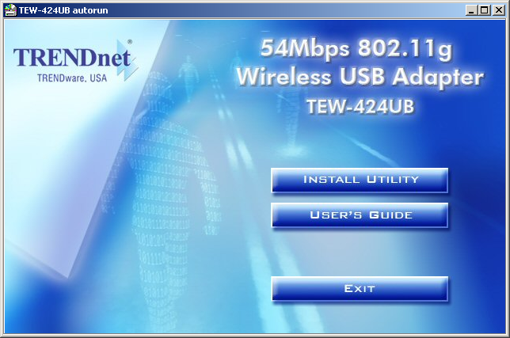 | – User’s Guide: click to preview the User's Guide in PDF format for detailed information of the USB adapter.  – Install Utility: click to install the Configuration Utility.  – Exit: click to close the Auto-Run program.

Installing the Configuration Utility
- Click Utility from the Auto-Run menu screen. Once executed, the Setup program will extract files to launch the InstallShield Wizard. Click Next in the welcome screen of the Install Shield Wizard.
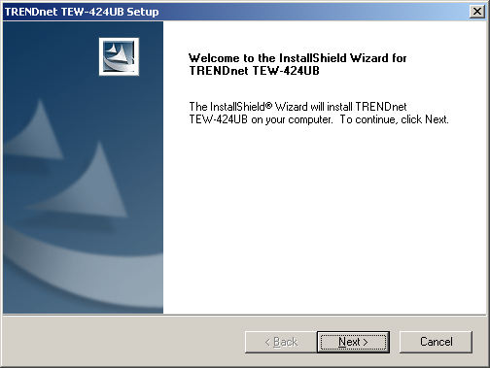
- Choose the Setup Type. If no specific requirement, leave the default setting (complete installation) and click Next.
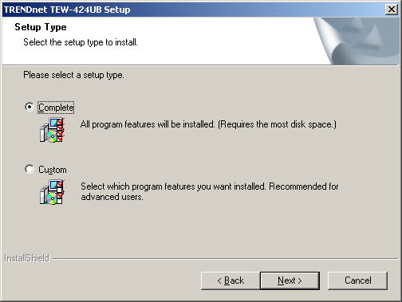
- Click Install to start software installation; the Progress bar will indicate the installation is proceeding.
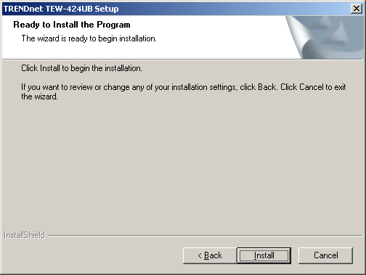
- When completed, click Finish.
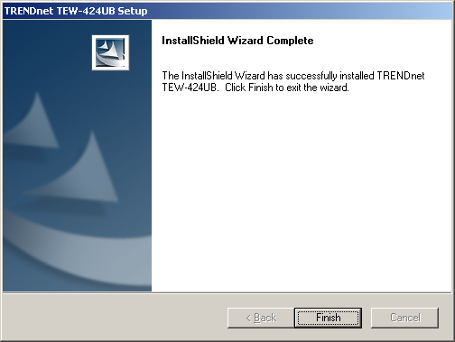

After installing the utility, the application program for the adapter is automatically installed to your computer, and creates a folder in Start\Programs\TRENDnet TEW-424UB Utility.

* If you use Windows® 2000/XP, it will appear a Digital Signature warning screen. Click Yes (Windows® 2000) or Continue Anyway (Windows® XP).
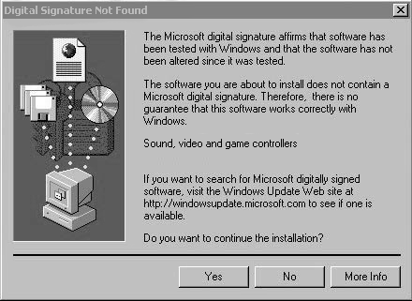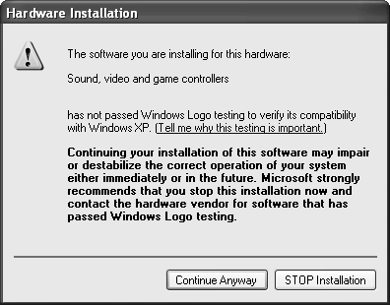
Windows® 2000 Windows® XP

After you have completed the software installation of your IEEE 802.11b/g USB2.0 Adapter, the TRENDnet TEW-424UB Utility icon 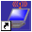 will appear on your desktop. Connect your TEW-424UB USB Adapter to your Laptop or Desktop; the windows will install the driver automatically.
Configuration Utility Status
Icon | Description
 | The wireless LAN is controlled by Windows Zero Configuration.
 | No connection.
 | Data is transferring under 802.11b mode.
 | Data is transferring under 802.11g mode.

Changing the Control Setting
If you use Windows® XP, you can choose to control your USB adapter using either the Windows “Zero Configuration Utility” or the adapter’s Configuration Utility. As default setting, the wireless network is controlled by the operating system. To take full advantage of the adapter, it is recommended to use the adapter’s Configuration Utility to configure your adapter and set up the network.
To change the control setting:
- Click Start > Settings > Control Panel to open the Control Panel window.
- Double-click the Network Connection icon to open the Networking Connection window.
- In the Networking Connection window, double-click on the Wireless Network Connection icon to bring up the following dialog window.
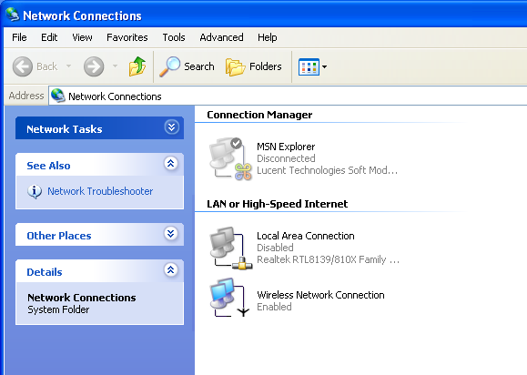
Double-click
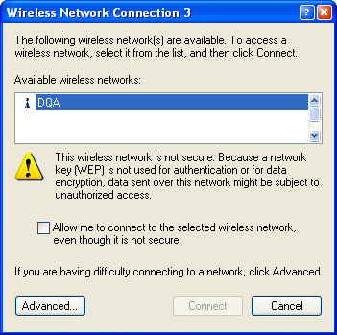
- Click Advanced to bring up the Properties window. Uncheck the “Use Windows to configure my wireless network settings” option. Then, click OK.
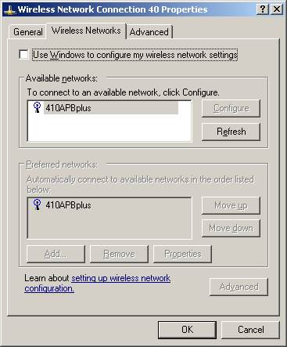
Uncheck this option

Now, you can use the adapter’s Configuration Utility to configure your network.

NOTE: If the adapter is controlled by Windows Zero Configuration Utility, the following warning window will appear when you click the TEW-424UB Utility icon.
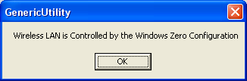

Using the Configuration Utility
After clicking on the Configuration Utility icon, the Link Info screen will display the settings for the adapter.

Link Info Screen
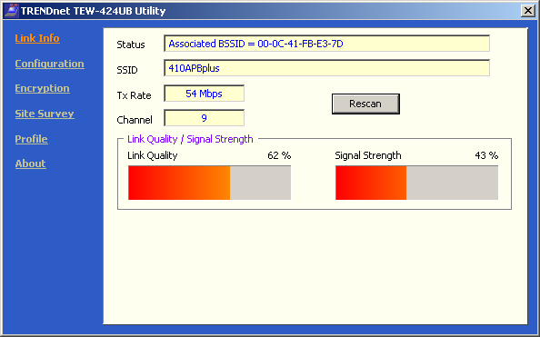

Status: Displays current connection state of the adapter.
SSID: The Service Set Identifier is the name assigned to the wireless network. It will auto-detect and display the SSID of wireless network connected in this field (eg. TEW-410APBplus).
Tx Rate: Tx Rate settings are automatically determined for an optimal speed up to a maximum of 54Mbps.
Channel: The adapter automatically determines the channel selection.
Link Quality: Displays the wireless signal strength for the wireless connection to the access point or router.
Rescan Button: Rescans for the strongest signal in your environment and associates with that access point or router.

Configuration Screen
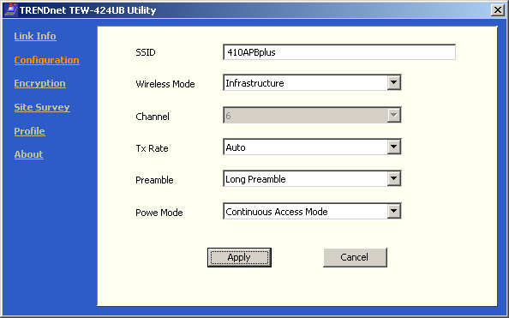

SSID: The Service Set Identifier is the name assigned to the wireless network. Make changes here to match the SSID on the existing wireless router or access point.
Wireless Mode: Infrastructure is the factory default setting used when associating with an Access Point or Router. Ad-Hoc mode is used for Peer-to-Peer networking with no Access Point or Router present.
Channel: The default channel setting is channel 6. In Infrastructure mode, the adapter will automatically select the channel to match the channel setting for the selected access point or router. In Ad-Hoc mode, the channel must be manually set to the same channel for each wireless adapter.
Tx Rate: You can adjust the transmission rate to get the best signal possible depending on your usage and your environment. The Tx Rate will be determined automatically by signal strength. Default is set to Auto.
Preamble: Preamble is a signal used in wireless environment to synchronize the transmitting timing including Synchronization and Start frame delimiter.
NOTE: If you want to change the Preamble type into Long or Short, please check the setting of AP.

Power Mode:
- Continuous Access Mode: this default setting consumes the most power.
- Maximum Power Save: this setting consumes the least power.
- Fast Power Save: this setting consumes a moderate amount of power.

Click Apply to save changes.

Encryption Screen
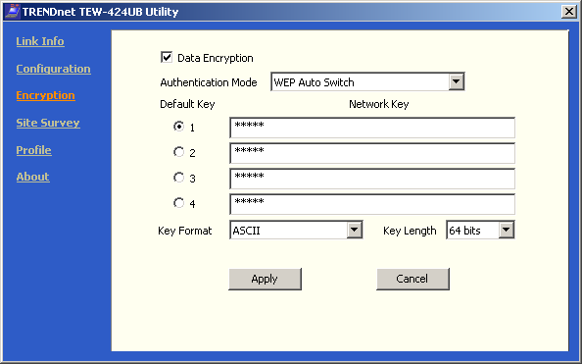

Data Encryption: Enable encryption by clicking in the box (check with a ✓ mark). This option is de-selected as the default setting.
Auth. Mode:
- WEP Open Authentication: transmits the key across the network.
- WEP Shared Authentication: allows communication only with other devices with identical WEP settings.
- WEP Auto Switch: will automatically adjust to the Authentication mode of the wireless access point or router.
Default Key: Enter a key in either ASCII or hexadecimal format. Select one of the 4 keys that you have created to be the default key.

Key Format: ASCII or hexadecimal format.
Key Length: Select the key length, either 64, 128 or 256 bits.

Click Apply if you have made any changes.

Hexadecimal digits consist of the numbers 0-9 and the letters A-F. ASCII (American Standard Code for Information Interchange) is a code for representing English letters as numbers from 0-127.

Site Survey Screen
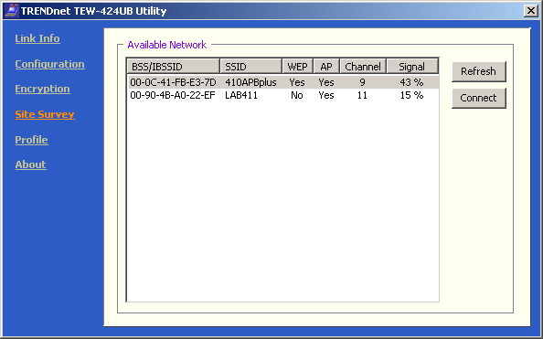

Available Networks: This field displays the Available Networks. To connect to one wireless network, scroll up and down in the list and highlight the desired network then click the Connect button.

NOTE: If you select a WEP-enabled wireless LAN to connect, such as 410APBplus in this manual, it will pop up a warning window to ask you to select the WEP setting. Click Yes to use your previous WEP setting; otherwise, click No.
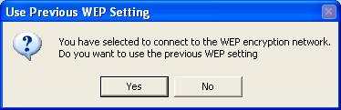

Profile Screen
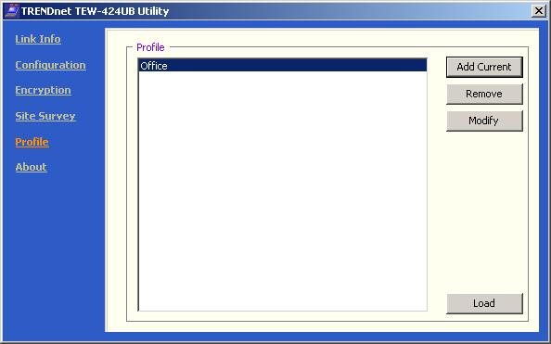

Profile: This field displays the saved wireless network connection(s). To add the current wireless network connection as a profile, click Add Current button.
In the screen, you can manage the profiles that you have created for the wireless network at home, at the office and in public places. Scroll up and down and highlight the profile that you wish to configure. You can add or remove a profile, or modify the configuration of the profile in order to connect with an available network. Also, you can click Load to load a saved network connection.
When you click Add Current or Modify button, the following dialog window will appear:

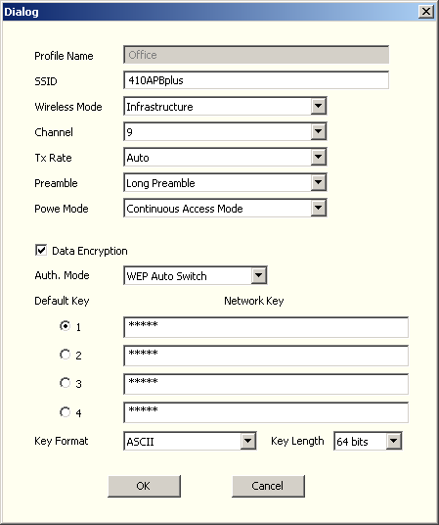
In this window you can configure all the properties of a profile in order to connect with a network of your choice.

Click OK to save the changes.

About Screen
This screen shows the general information of your adapter and utility, including the utility version, driver version, and the adapter’s MAC address.
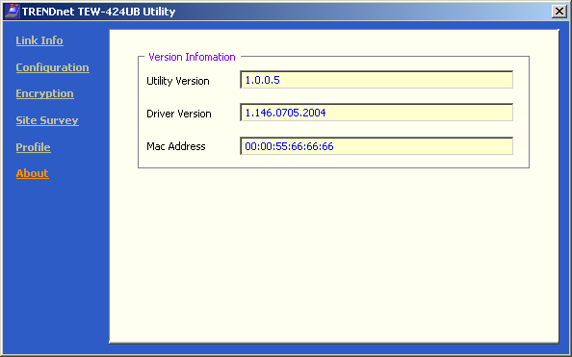

4

Product Specifications

Interface and Standard
‧USB 2.0
‧IEEE 802.11g, IEEE802.11b, Wi-Fi compliant

Number of Selectable Channels
‧USA & Canada: 11 channels
‧Europe: 13 channels

Frequency Range
2.412GHz ~ 2.4835GHz:
‧2.412 ~ 2.462 GHz (North America)
‧2.412 ~ 2.484 GHz (Japan)
‧2.412 ~ 2.472 GHz (Europe ETSI)
‧2.457 ~ 2.462 GHz (Spain)
‧2.457 ~ 2.472 GHz (France)

Data rate
‧802.11g: 54, 48, 36, 24, 18, 12, 9, 6Mbps
‧802.11b: 11, 5.5, 2, 1Mbps

Modulation Technique
‧802.11g: Orthogonal Frequency Division Multiplexing (64QAM,
16QAM, QPSK, BPSK)
‧802.11b: Direct Sequence Spread Spectrum (CCK, DQPSK,
DBPSK)

Security
64, 128, 256-bit WEP

Media Access Protocol
CSMA/CA (Collision Avoidance) with optional ACK

Operating System Support
Microsoft® Windows 98SE/ME/2000/XP

LEDs
Link, ACT

Environmental and Physical
‧Weight: 20 g
‧Dimension: 73 (L) x 29.5 (W) x 10.6 (H) mm
‧Operating Voltage: 5V DC
‧Operating Temperature: 0°C to 50°C
‧Storage Temperature: -10°C to 65°C
‧Operating Humidity: 90%, non-condensing
‧Storage Humidity: 95%, non-condensing

EMI Compliance
‧FCC Part15 in US
‧EN300328 and EN300826 (EN301489-17) in Europe
Limited Warranty

TRENDware warrants its products against defects in material and workmanship, under normal use and service, for the following lengths of time from the date of purchase.

Wireless Products – 3 Years Warranty

If a product does not operate as warranted above during the applicable warranty period, TRENDware shall, at its option and expense, repair the defective product or part, deliver to customer an equivalent product or part to replace the defective item, or refund to customer the purchase price paid for the defective product. All products that are replaced will become the property of TRENDware. Replacement products may be new or reconditioned.

TRENDware shall not be responsible for any software, firmware, information, or memory data of customer contained in, stored on, or integrated with any products returned to TRENDware pursuant to any warranty.

There are no user serviceable parts inside the product. Do not remove or attempt to service the product by any unauthorized service center. This warranty is voided if (i) the product has been modified or repaired by any unauthorized service center, (ii) the product was subject to accident, abuse, or improper use (iii) the product was subject to conditions more severe than those specified in the manual.

Warranty service may be obtained by contacting TRENDware office within the applicable warranty period for a Return Material Authorization (RMA) number, accompanied by a copy of the dated proof of the purchase. Products returned to TRENDware must be pre-authorized by TRENDware with RMA number marked on the outside of the package, and sent prepaid, insured and packaged appropriately for safe shipment.

WARRANTIES EXCLUSIVE: IF THE TRENDWARE PRODUCT DOES NOT OPERATE AS WARRANTED ABOVE, THE CUSTOMER’S SOLE REMEDY SHALL BE, AT TRENDWARE’S OPTION, REPAIR OR REPLACEMENT. THE FOREGOING WARRANTIES AND REMEDIES ARE EXCLUSIVE AND ARE IN LIEU OF ALL OTHER WARRANTIES, EXPRESSED OR IMPLIED, EITHER IN FACT OR BY OPERATION OF LAW, STATUTORY OR OTHERWISE, INCLUDING WARRANTIES OF MERCHANTABILITY AND FITNESS FOR A PARTICULAR PURPOSE. TRENDWARE NEITHER ASSUMES NOR AUTHORIZES ANY OTHER PERSON TO ASSUME FOR IT ANY OTHER LIABILITY IN CONNECTION WITH THE SALE, INSTALLATION MAINTENANCE OR USE OF TRENDWARE’S PRODUCTS.

TRENDWARE SHALL NOT BE LIABLE UNDER THIS WARRANTY IF ITS TESTING AND EXAMINATION DISCLOSE THAT THE ALLEGED DEFECT IN THE PRODUCT DOES NOT EXIST OR WAS CAUSED BY CUSTOMER’S OR ANY THIRD PERSON’S MISUSE, NEGLECT, IMPROPER INSTALLATION OR TESTING, UNAUTHORIZED ATTEMPTS TO REPAIR OR MODIFY, OR ANY OTHER CAUSE BEYOND THE RANGE OF THE INTENDED USE, OR BY ACCIDENT, FIRE, LIGHTNING, OR OTHER HAZARD.

LIMITATION OF LIABILITY: TO THE FULL EXTENT ALLOWED BY LAW TRENDWARE ALSO EXCLUDES FOR ITSELF AND ITS SUPPLIERS ANY LIABILITY, WHETHER BASED IN CONTRACT OR TORT (INCLUDING NEGLIGENCE), FOR INCIDENTAL, CONSEQUENTIAL, INDIRECT, SPECIAL, OR PUNITIVE DAMAGES OF ANY KIND, OR FOR LOSS OF REVENUE OR PROFITS, LOSS OF BUSINESS, LOSS OF INFORMATION OR DATE, OR OTHER FINANCIAL LOSS ARISING OUT OF OR IN CONNECTION WITH THE SALE, INSTALLATION, MAINTENANCE, USE, PERFORMANCE, FAILURE, OR INTERRUPTION OF THE POSSIBILITY OF SUCH DAMAGES, AND LIMITS ITS LIABILITY TO REPAIR, REPLACEMENT, OR REFUND OF THE PURCHASE PRICE PAID, AT TRENDWARE’S OPTION. THIS DISCLAIMER OF LIABILITY FOR DAMAGES WILL NOT BE AFFECTED IF ANY REMEDY PROVIDED HEREIN SHALL FAIL OF ITS ESSENTIAL PURPOSE.
Governing Law: This Limited Warranty shall be governed by the laws of the state of California.

Technical Support

You can find the most recent driver/firmware/software and user documentations on the TRENDware website. TRENDware provides FREE technical support for all customers for the duration of the warranty period on this product.

TRENDware Technical Support
Tel: +1-310-626-6252
Fax: +1-310-626-6267

E-mail: support@trendware.com
www.TRENDnet.com

Monday ~ Friday, 7:00AM ~ 6:00PM Pacific Standard Time
(Except holidays)


