

ClearSky ™ Bluetooth VoIP Phone Kit (for Skype™)

The ClearSky Bluetooth VoIp Phone provides a cost effective solution that allows you to make phone calls anywhere around the world. Streamline calling procedures by taking advantage of SkypeTM features such as Contacts, Call List, SkypeOut, and Conference Call. The rechargeable Lithium-ion battery can also sustain 6 hours of conversation.

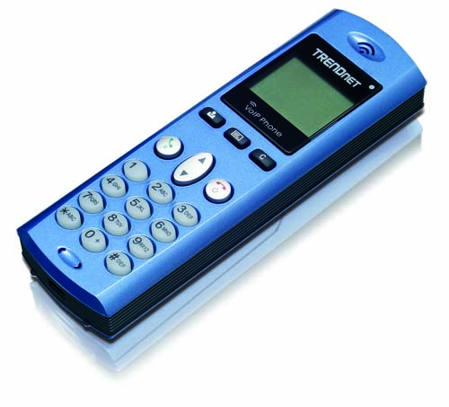
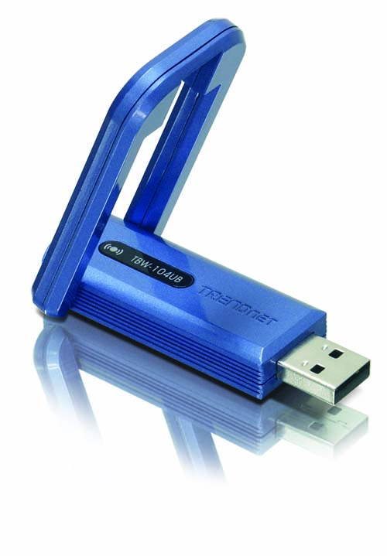

TVP-SP1BK

Features
- Compliant with Bluetooth v2.0 Specification with EDR (Enhanced Data Rate) support
- Backward compatible with Bluetooth v1.1 and v1.2 devices
- Compliant with Class I Bluetooth Operations
- Support Full-Speed Bluetooth operation with Full Piconet support
- Support Graphical LCD display with status Indicators
- Support Long Life Lithium Rechargeable Battery
- Headset support for voice communication such as Skype, MSN Messenger, Yahoo Messenger and more
- Full Skype support allows users to use Skype features directly from the phone (such as SkypeIn™ calls, SkypeOut™, Status change, Conference Call and etc.)
- Compatible with Windows Windows 2000/XP Operating Systems
- ClearSky Long Range Support up to 100 meters (328 ft.) (depends on the environment)
- 2-Year Warranty
Specifications
Hardware
Standards | Class I Bluetooth v2.0 with EDR  Backward Compatible with Bluetooth v1.1, v1.2
Headset Interface | Mini-B USB Connector for charging  Earphone Jack (2.5mm)  Built-in Speakerphone
Adapter Interface | USB 1.1, 2.0 / External Dipole Antenna
Display | 96 x 64 pixel (STN LCD with back light)
LED Indicator | Headset Status (Active, Standby, Sleep)
Battery | 3.6V 700mAh Lithium-ion Rechargeable Battery
Cable | Type A to Mini-B USB Cable (1m / 3ft.) for charging
Power Consumption | Standby Time : 60+ hours  Talk Time : 6+ hours
Dimensions | Headset: 143.5 x 45 x 22 mm (5.6 x 1.78 x 0.9 in.)  Adapter: 71.25 x 35.6 x 11.25 mm (2.8 x 1.4 x 0.44 in.)
Unit Weight | Headset: 100 g (3.5 oz.) / Adapter: 10 g (0.35 oz.)
Temperature | Operation: 0°~ 50°C (32°F~122°F); Storage: -20°~ 70°C (-4°F~158°F)
Humidity | 10~90%
Certification | CE, FCC
Phone Features
Volume | Volume up: Vol +; Volume down: Vol -
Skype Support | - Sync Contact list, History, SkypeIn, SkyOut  - Conference Call, Skype Credit Status  - Support Status Change (Online, Offline, Skype Me, Away, Not Available, Do not Disturb and Invisible)
Bluetooth
Frequency | 2.4 ~ 2.4835 GHz ISM Band
Spread Spectrum | Frequency Hopping and Adaptive Frequency Hopping
RF Output Power | 17dBm (typical)
Receiving Sensitivity | -90dBm@0.1%BER ( typical )
Date Range | Up to 100m (328 ft.) depends on environment



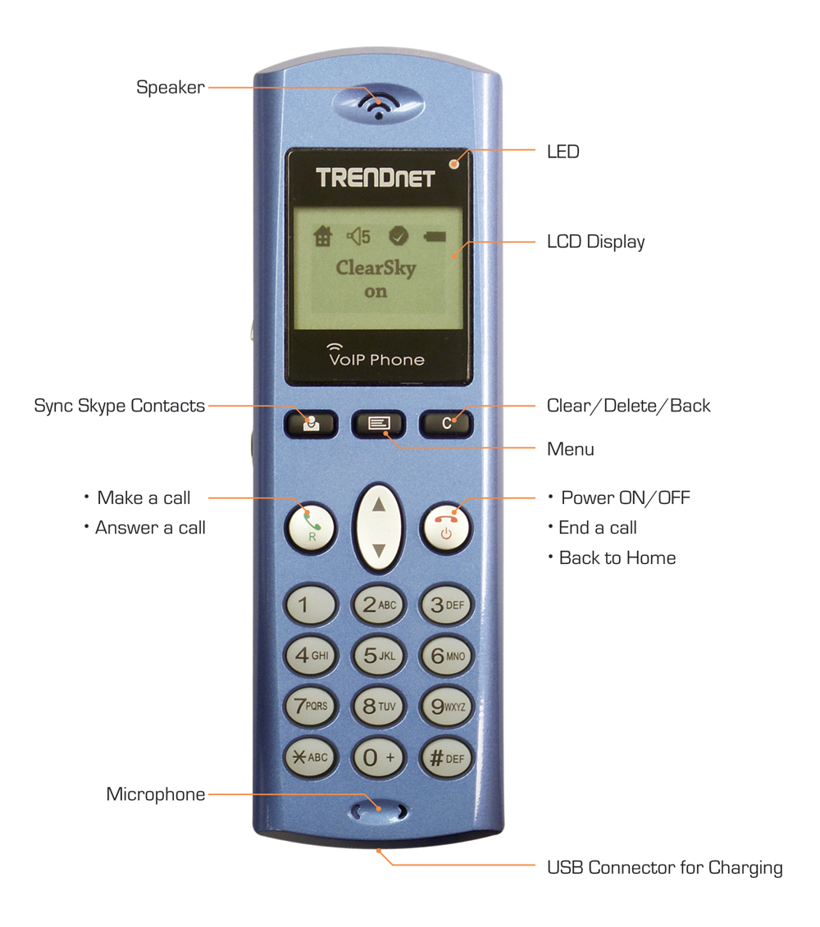

Package Contents Related Products

- TVP-SP1B - TBW-101UB
- TBW-104UB - TBW-102UB
- Lithium-ion Rechargeable Battery - TBW-103UB
- Multi-Language Quick Installation Guide
- CD-ROM (Driver/User’s Guide)
- USB Cable (1m/3 ft.)

To order please call: 888-326-6061 • Sales: sales@trendware.com
Support: techsupport@trendware.com • Tech Support Hotline: 1(310) 626-6252
Official Site: www.TRENDnet.com

