


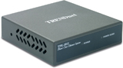
Power over Ethernet (PoE) Injector

TRENDnet’s TPE-101I Power over Ethernet Injector provides an innovative and cost effective solution to a variety of Ethernet devices such as VoIP phones or Wireless Access Points. Reduce costs by using existing CAT5 cable to deliver both power and data where power source is difficult to obtain.

TPE-101I
Features
- IEEE 802.3af Power over Ethernet (PoE) Standard Compliant
- Reduce Cabling for Wireless APs, IP Phone and any IEEE 802.3af Powered Device (PD)
- Supplies Power to PD up to 15.4 watts
- Automatically detecting PoE Terminals and Supplying Inline Power
- Advanced Auto-Sensing Algorithm Giving Power only to 802.3af end device
- High Safety Standards with Short Circuit Protection
- Auto Disconnection for Over Voltage or Under Voltage Situation
- Supports Power Detection and Classification
- 5-Year Warranty
Specifications
Hardware
Standard | IEEE 802.3 10Base-T  IEEE802.3u 100Base-TX  IEEE 802.3af Power Over Ethernet
Network Media | 10Mbps: Cat 3,4,5 Unshielded/Shielded/Screened Cable  100Mbps: Cat 5, 5E, 6 Unshielded/Shielded/Screened Cable
Protocol | CSMA/CD
Topology | Star
Ports | 1 x DATA-IN Port (Data only)  1 x POE-OUT Port (Data + Power)
Power | Input: 48V 0.5A (External Power Adapter)  Output: Class 0, 48V DC @ 15.4 watts ; Class 1, 48V DC @ 4 watts  Class 2, 48V DC @ 7 watts ; Class 3, 48V DC @ 15.4 watts
Diagnostic LEDs | Power (Green)  Power Good (Green)
Power Consumption | 24 watts (max)
Temperature | Operation: 0°C~40°C (32°F~ °F)  Storage: -10°C~70°C (°F~ °F)
Humidity | 10%- 90% (non-condensing)
Dimensions | 87 x 85 x 24mm (3.425 x 3.35 x 0.95 inches) (L x W x H)
Weight | 156g (0.35 lb)
Certification | FCC, CE
Image | 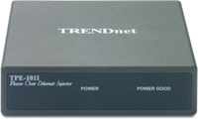  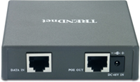

Power over Ethernet Solutions

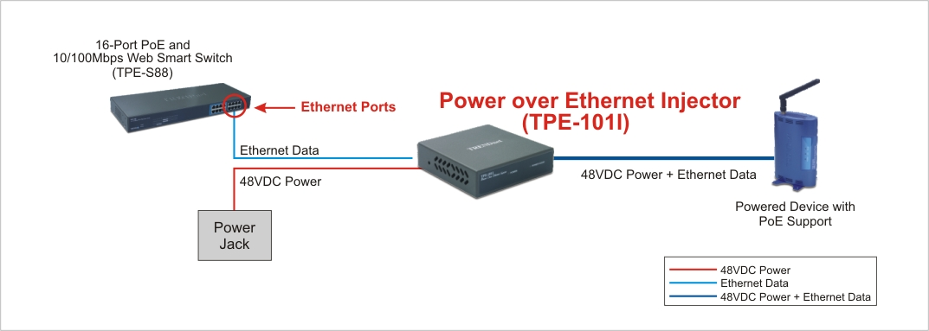

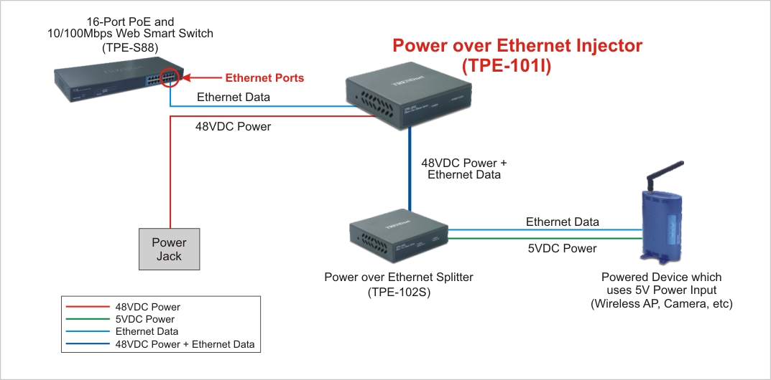

Package Contents Related Product
- TPE-101I - TPE-102S
- Multi-Language User’s Guide - TPE-S88
- Power Adapter (48VDC, 0.5A)

To order please call: 888-326-6061
3135 Kashiwa Street • Torrance, CA 90505 • (310) 891-1100 • Fax: (310) 891-1111

Sales: sales@trendware.com • Support: techsupport@trendware.com
Tech Support Hot Line: 1-310-626-6252

Official Site: www.TRENDNET.com

