

TEW-OA24D 24dBi Outdoor Directional Antenna

TEW-OA24D 24dBi High Gain Outdoor Reflector Grid Antenna provides extended coverage range for your existing 802.11b or 802.11g Wireless Local Area Network (WLAN). TEW-OA24D comes with female N-type antenna connector; with optional conversion cable (male N-type to female Reverse SMA). TEW-OA24D is weatherproofed; you can mount it outdoor on the wall or on a pole. The antenna also has a tilted bracket for antenna alignment. Expand the power of your wireless product with TRENDnet's TEW-OA24D.

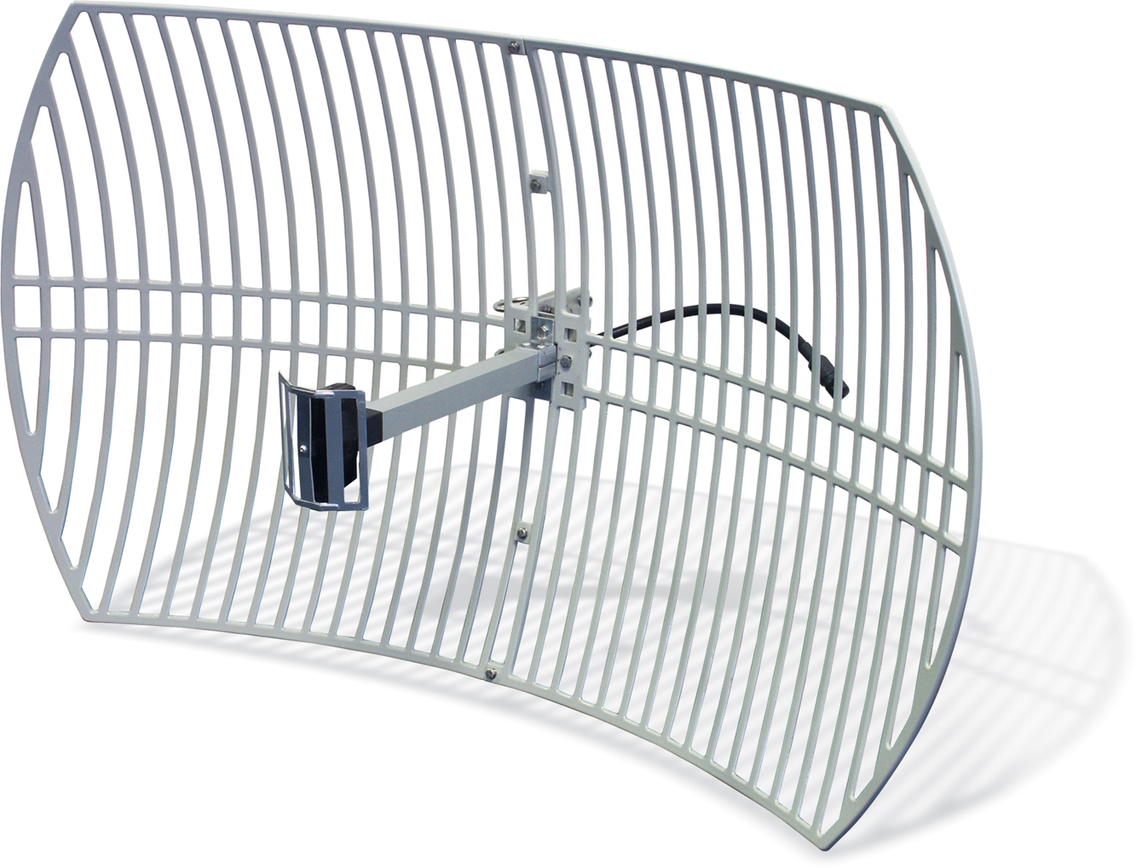


TEW-OA24D (v2.0R)

Specifications
Pattern

Frequency range: | 2.4GHz ~ 2.5GHz  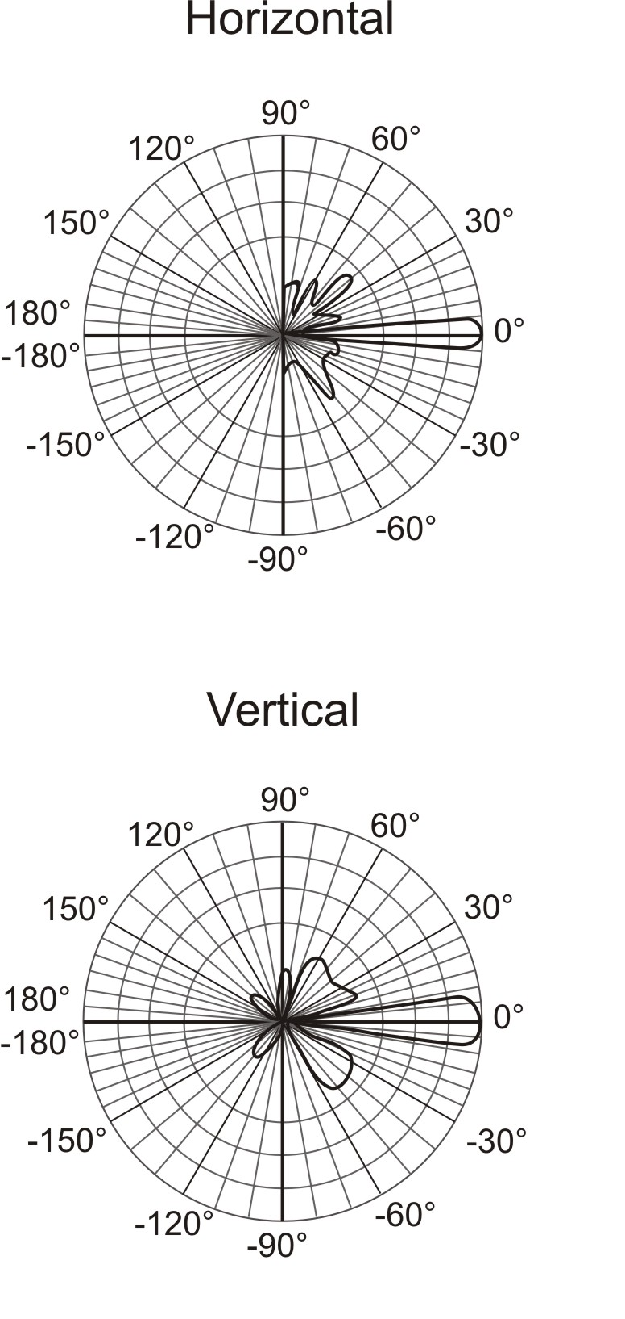
Gain: | 24 dBi
VSWR: | 1.5 : 1 Max
Polarization: | Linear, Vertical
HFBW Vertical | 14 º
HFBW Horizontal | 10 º
Front to Back Ratio: | 30dB
Up/Down tilt: | 60 º
Power Handling: | Max. 100 W (cw)
Impedance: | 50 Ohms
Connector Lead Cable: | RG-58/u, 30 cm (12 inches)
Connector Type: | N-Type Female
Survival Wind Speed: | 216 Km/hr (134 Miles/hr)
Temperature: | -40 ºC ~ 80 ºC (-40 ºF ~ 176 ºF)
Humidity: | 100% @ 25 ºC (77 ºF)
Lightning Protection: | DC Ground
Antenna Type: | Directional, Grid type
Mount Style: | Pole end mounting.  Pole diameter 50mm  (2 inches) max.
Weight: | 3.5 Kg (7.7 lb)
Dimensions (WxHxD):  (Final product) | 90 x 60 x 50 mm  (35.4 x 23.5 x 19.5 inches)
Warranty: | 3 Years
NOTE: For optimal results in extending your wireless range with wireless antenna installations, we recommended that you consult a professional installer for site survey, safety precautions, and proper installation.

PRODUCT
INFORMATION

To order please call: 888-326-6061
20675 Manhattan Place • Torrance, CA 90501 • (310) 891-1100 • Fax: (310) 891-1111
sales@trendnet.com • techsupport@trendnet.com

