
54Mbps 802.11g Wireless Firewall Router

The 54Mbps Wireless G Router offers a complete wireless solution that allows you to share files, an Internet connection, or network resource while protecting your network using enhanced security features. Simply plug your workstations and your broadband modem into the Wireless G router, and configure your broadband connection using its built-in Web Interface. Use the Virtual Server feature to configure any workstation as a Web Server or FTP server easily, allowing users to view files from the Internet. You can also protect your Wireless LAN using 64/128-bit WEP encryption or industry standard WPA-PSK with TKIP or AES algorithms. Increase security by enabling MAC, IP, or Protocol Filtering as well as setting Firewall Rules to limit Internet Access or block malicious intruders from accessing your network.
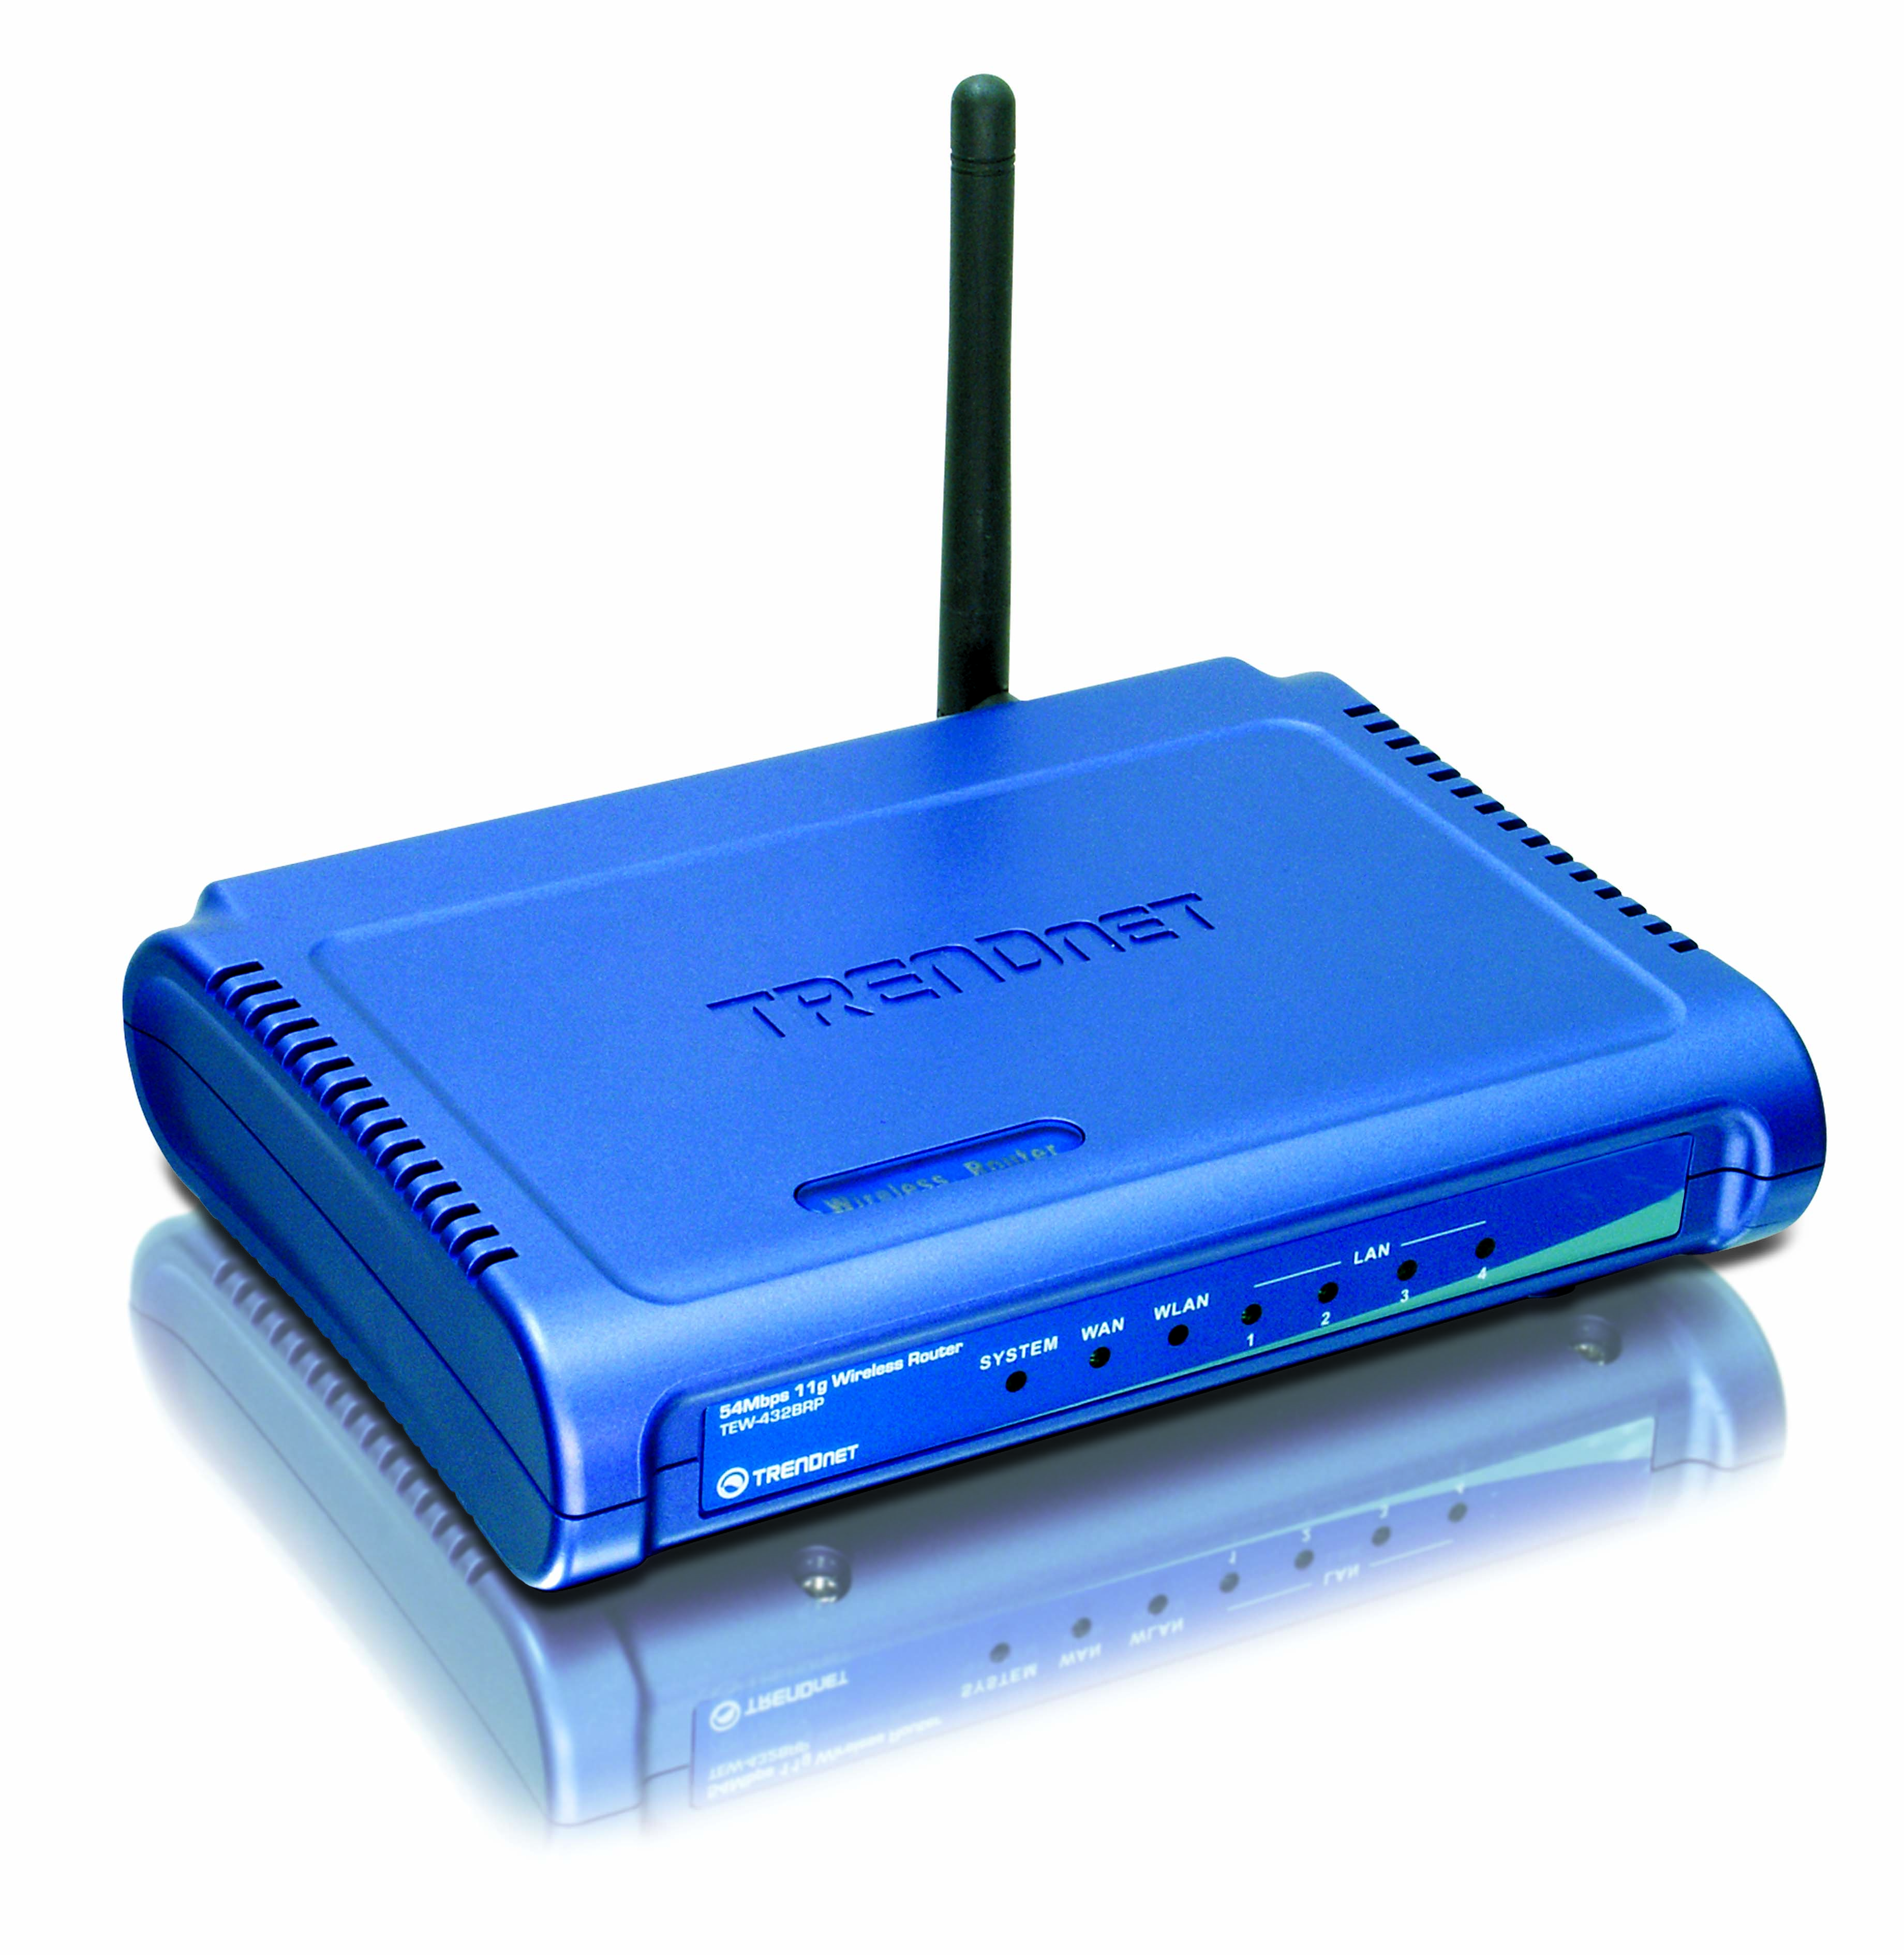
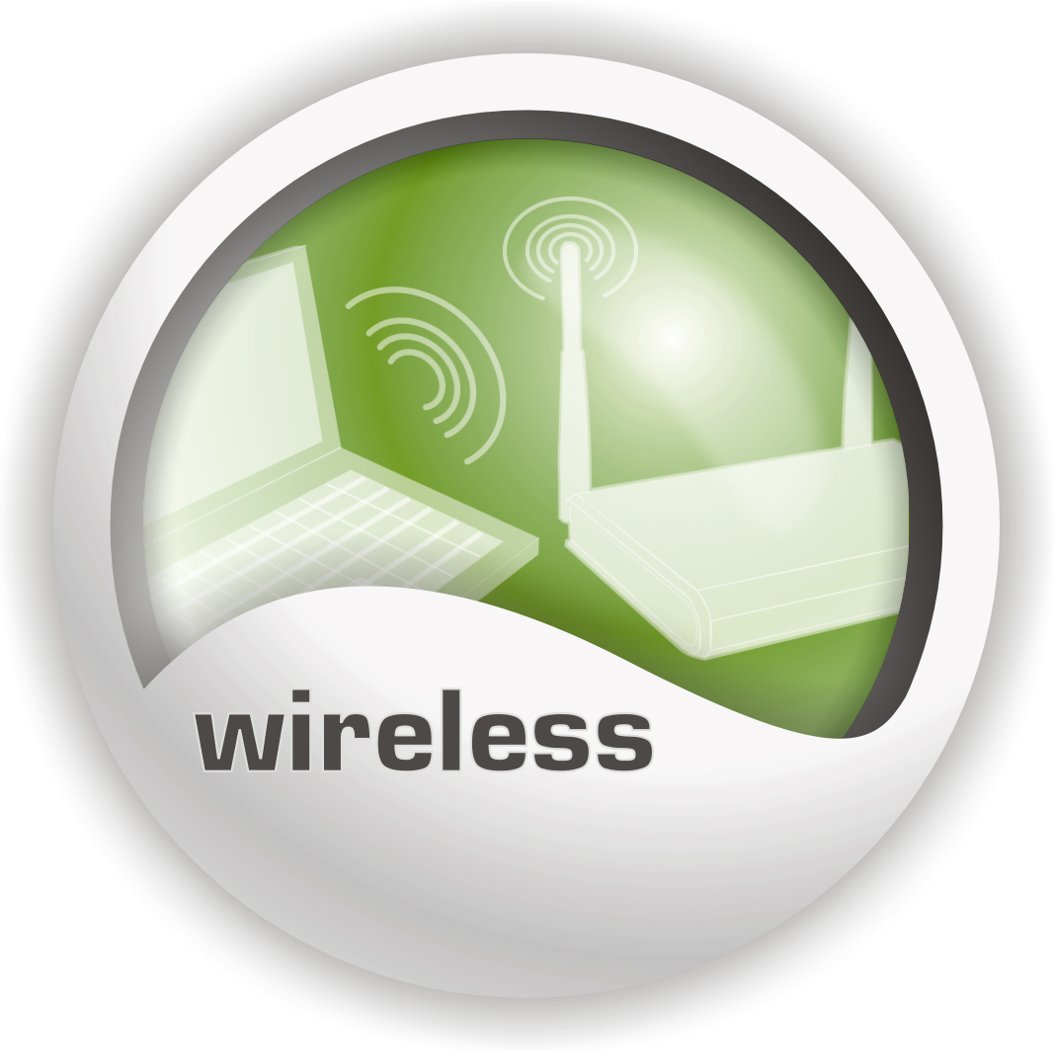


TEW-432BRP (C1.0R)
Features
- Wi-Fi Compliant with IEEE 802.11g and 802.11b Devices
- Built-in 4 x 10/100Mbps Auto-MDIX LAN Ports
- Built-in 1 x 10/100Mbps Auto-MDIX WAN Port (Internet)
- Supports Cable/DSL Modems with Dynamic IP, Static IP, PPPoE, PPTP or L2TP Connection Types
- DHCP Server Feature Allocates up to 253 Client IP Addresses
- Supports 64/128-bit Wired Equivalent Privacy (WEP)
- Supports 802.1x WPA/WPA2, WPA-PSK/WPA2-PSK, TKIP/AES for Advance Security
- Supports MAC Address, Protocol, IP Filters and UPnP (Universal Plug & Play)
- Supports Domain and URL blockings
- Traffic Control with Virtual Server, Virtual PC mapping and DMZ
- Provides Additional Security with SPI / NAT firewall and Attack Alert via emails
- Provides Additional Security of Enable/Disable SSID, Password Protection
- Supports Static and Dynamic Routing
New Implements

- Chipset change → Atheros
- Add WPA2 support
- Supports IPSec and PPTP VPN Pass-Through Sessions
- Flash Memory for Firmware Upgrade, Save/Restore Settings, and Traffic Log
- Compliant with Windows 95/98/NT/2000/XP, Linux and Mac OS
- Easy Management via Web Browser (HTTP) and Remote Management
- Range for Indoor of 30 ~ 50 meters (depends on the environment)
- Range for Outdoor of 50 ~ 200 meters (depends on the environment)
- 3-Year Warranty
Specification

Hardware
Standards | Wired: IEEE 802.3 (10Base-T), IEEE 802.3u (100Base-TX), ANSI/IEEE 802.3 Auto Negotiation  Wireless: IEEE 802.11b (11Mbps), IEEE 802.11g (54Mbps)
WAN | 1 x 10/100Mbps Auto-MDIX Port (Internet)
LAN | 4 x 10/100Mbps Auto-MDIX Port
Connection Type | Dynamic IP, Static (Fixed) IP, PPPoE, PPTP
Supported Network Protocols | TCP/IP, NAT, PPPoE/PPTP, HTTP, DHCP Server/Client
LED Indicators | System, WAN, WLAN, LAN
Dimension (L x W x H) | 155 x 110 x 30 mm (6 x 4.3 x 1.2 inches)
Weight | 226g (8 oz.)
Temperature | Operation: 0°~ 40°C (32°F~ 104°F) Storage: -10°~ 70°C (14°F~ 158°F)
Humidity | Max. 95% (Non-Condensing)
Power Adapter | 7.5V DC, 1A External Power Adapter
Certification | FCC & CE

Wireless
Frequency | 2.412 ~ 2.484GHz (Industrial Scientific Medical Band)
Module Technique | 802.11b: CCK (11 and 5.5Mbps), DQPSK (2Mbps), DBPSK (1Mbps)  802.11g: OFDM
Antenna | 1 x 2dBi External Detachable Dipole Antenna (Female Reverse SMA Connector)
Media Access Protocol | CSMA/CA with ACK
Security | 64/128-bit WEP (HEX/ASCII), 802.1x WPA/WPA2, WPA-PSK/WPA2-PSK, MAC Address Filter, Protocol Filter
Transmit Power | 13 dBm (typically)
Data Rate | 802.11b: 11Mbps, 5.5Mbps, 2Mbps, and 1Mbps  802.11g: 54Mbps, 48Mbps, 36Mbps, 24Mbps, 18Mbps, 12Mbps, 9Mbps and 6Mbps
Receiving Sensitivity | 11Mbps 8% PER @ -85 dBm (typical)  54Mbps 10% PER @ -70 dBm (typical)
Channels | 11 Channels (US), 13 Channels (EU)

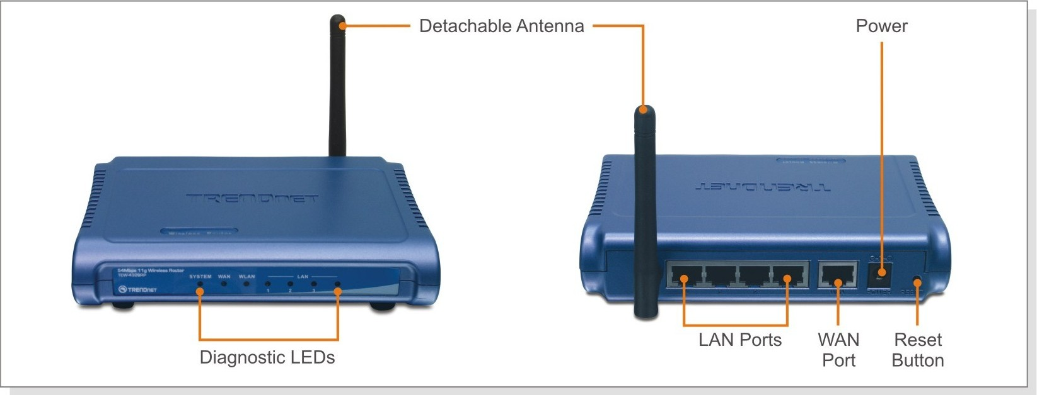

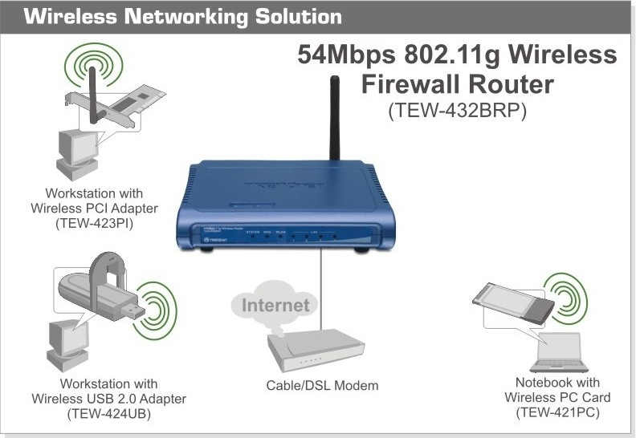

Package Contents Related Products
- TEW-432BRP - TEW-421PC
- Multi-Language QIG - TEW-423PI
- CD-ROM (User’s Guide) - TEW-424UB
- Power Adapter (7.5V, 1A) - TEW-430APB
- RJ-45 Cat. 5 Cable (1.5M)

To order please call: 888-326-6061
3135 Kashiwa Street • Torrance, CA 90505 • (310) 891-1100 • Fax: (310) 891-1111
Sales: sales@trendnet.com • Support: techsupport@trendnet.com
www.TRENDnet.com

