


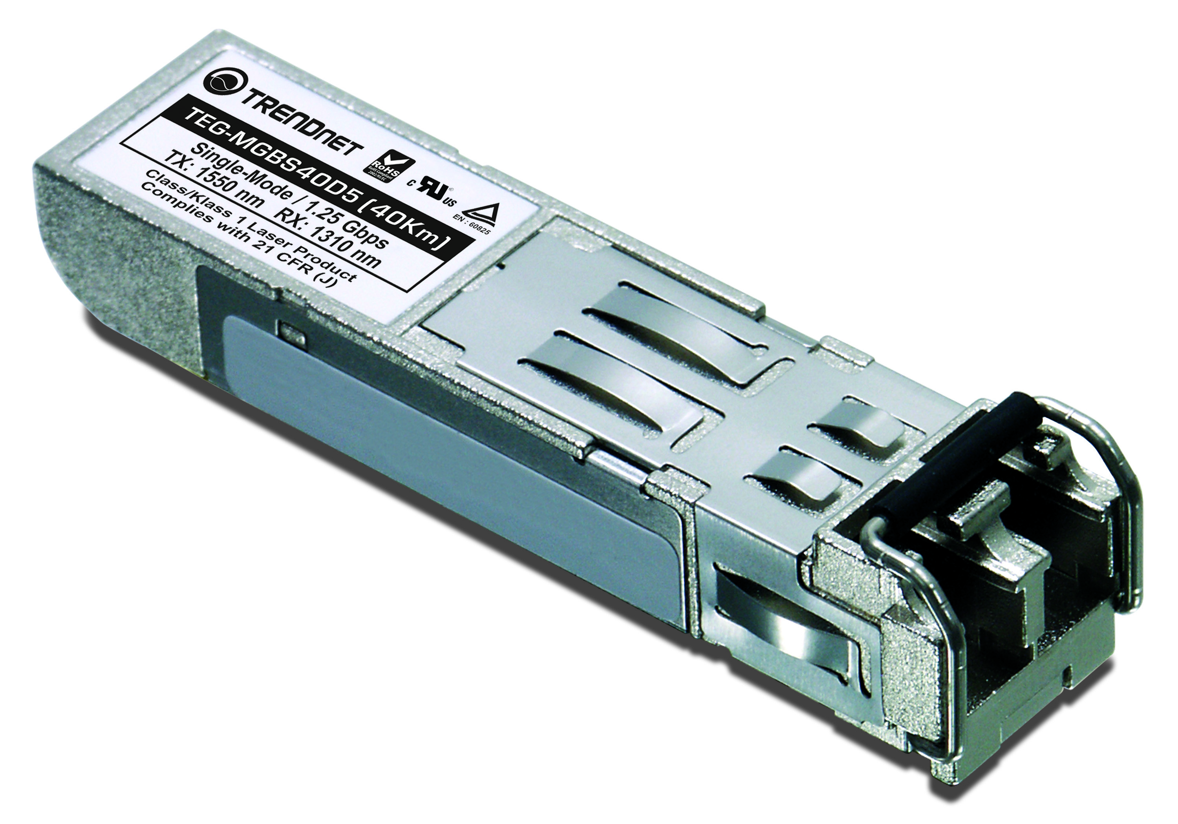
Dual Wavelength Mini-GBIC Modules

1000Mbps-LX Mini-GBIC WDM modules are designed to connect with any Gigabit Ethernet Switch with an industry standard Mini-GBIC slot. These RoHS-compliant single-mode modules support distances up to 40 kilometers. These Small Form Factor Pluggable (SFP) modules utilize an advanced metal design to minimize Electromagnetic Interference (EMI). The modules provide a powerful, hot-pluggable solution for server, multi-processing and switch-to-switch applications.

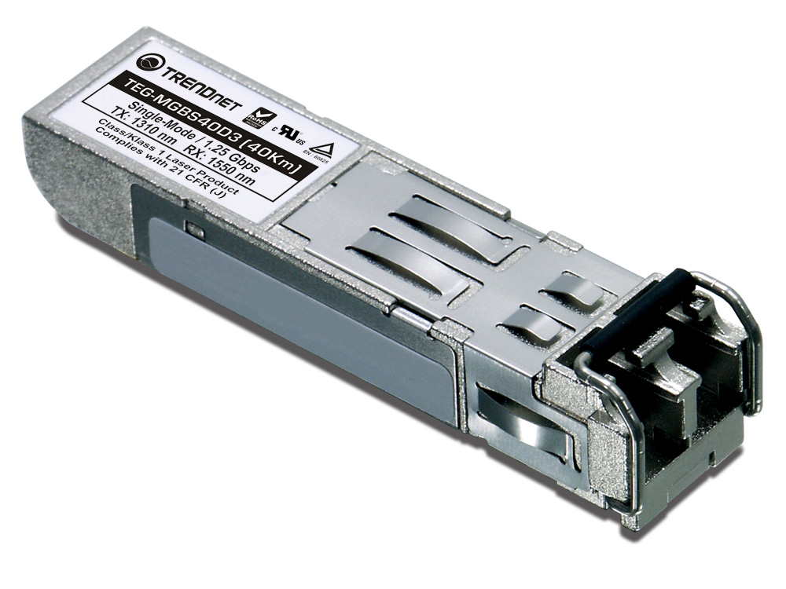

TEG-MGBS10D35 (V1.0R)

Features
- Compliant with IEEE 802.3z Gigabit Ethernet and Fiber Channel Standards
- Compliant with SFP MSA, SONET/SDH standards, Class 1 laser products, EN 60825, and EN60950
- Metal Enclosure, low EMI
- Duplex LC connector
- Hot Pluggable and Low Power Dissipation
- Single 3.3V Power Supply Voltage

Specifications
Model Name | Wavelength | Power Budget | Sensitivity | Pout | Distance
TEG-MGBS10D3 | TX: 1310nm  RX: 1550nm | 11dBm | -20 | -9 ~ -3 dBm | 10km
TEG-MGBS10D5 | TX: 1550nm  RX: 1310nm | 11dBm | -20 | -9 ~ -3 dBm | 10km
TEG-MGBS40D3 | TX: 1310nm  RX: 1550nm | 20dBm | -23 | -3 ~ +3 dBm | 40Km
TEG-MGBS40D5 | TX: 1550nm  RX: 1310nm | 20dBm | -23 | -3 ~ +3 dBm | 40Km

Application
- Metro Access Rings
- Point-to-Point Networking
- Suitable for Fast Ethernet and OC-12
- 5-Year Warranty

To order please call: 888-326-6061
20675 Manhanttan Place • Torrance, CA 90501 • (310) 961-5500 • Fax: (310) 961-5511
Tech Support Hotline: 1-310-626-6252

Sales: sales@trendnet.com • Support: support@trendnet.com
Official Site: www.TRENDnet.com

