



ADSL/ADSL2+ Ethernet / USB
Combo Modem Router

The TDM-C400 is ADSL/ADSL2+ customer premise equipment that provides high-speed asymmetrical data transmission on a single twisted copper pair. The DSL line interface supports various ADSL standards, up to ADSL2+. At the DTE side these CPEs provide, dual interfaces, a 10/100 Ethernet interface and one USB port for easy connection to user’s PC or LAN environment. TDM-C400 delivers broadband access for enterprises, telecommuters, home, and remote office workers with high-speed data transfer requirements.

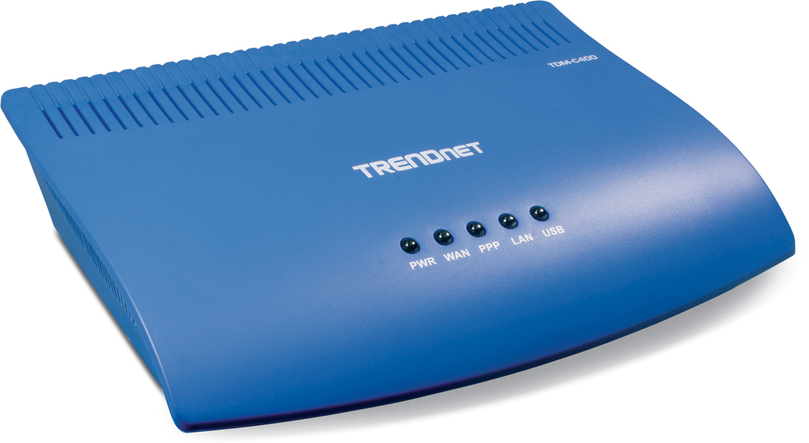
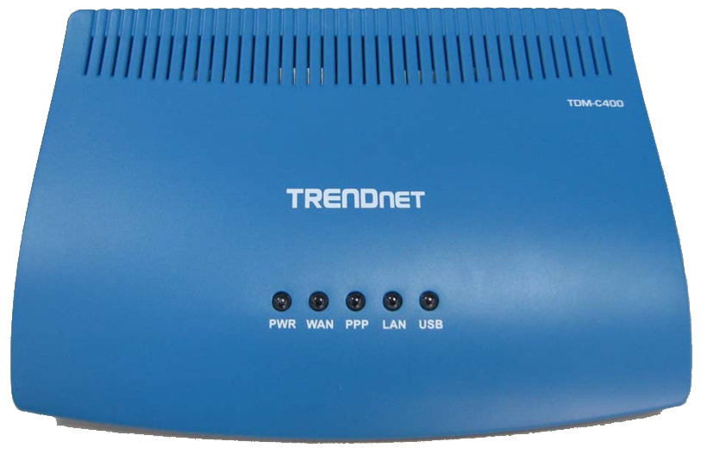

TDM-C400 (v1.0R)

Features

- Compliant with ITU-T G.992.1 (G.dmt), G.992.2 (G.lite) and ANSI T1.413 Issue 2
- TDM-C400 is additionally compliant with ITU-T G.992.3 (G.dmt.bis / ADSL2), G.992.5 (ADSL2+) and provides up to 24 Mbps downstream rate
- Compatible and interoperable with major Central Office side ADSL DSLAM or Multi-service Access System
- One 10/100 Base-TX Ethernet port and one USB 1.1 device port for PC / LAN connection
- RFC2684 / 1483 to bridge or route traffic over ATM over ADSL
- Support Networking protocols such as PPP, IP routing, NAPT, relay / client
- Support local and remote configuration and management through Web, Telnet or SNMP
- Simple firmware upgrade via TFTP, FTP or HTTP
- 5-Year Warranty
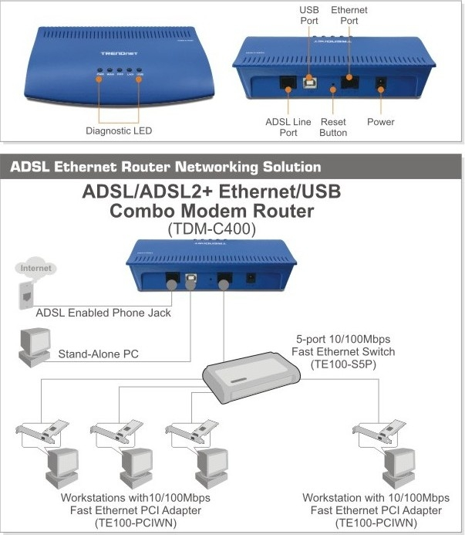

Specifications
Hardware
LAN Interface | One 10/100 Base-TX Ethernet port, IEEE 802.3/3u, RJ-45 connector  One USB 1.1 device port, type B connector
WAN Interface  (ADSL line) | One pair (2-wire) loop, 100 Ω line impedance with RJ-11 connector  Compliance: ITU-T G.992.1, G.992.2 and ANSI T1.413 Issue 2 (Annex A)  Compliance: ITU-T G.992.1, G.992.2, G.992.3, G.992.5 & ANSI T1.413 Issue 2
Indicators | USB (green LED) – Continuous ON when USB is  active; blinking while transmitting / receiving data  LAN (green LED) – Continuous ON when Ethernet is  active; blinking while transmitting / receiving data  PPP (green LED) – Continuous ON when PPP connection is established;  blinking while transmitting / receiving data  WAN (green LED) – Continuous ON when ADSL link is up  PWR (green LED) – Continuous ON when power is properly connected
OAM&P | Local: Telnet or Web management via Ethernet  Remote: Telnet or Web Management
Power | AC adapter: Input 110/220VAC, 50/60Hz; Output 15VAC 1A  Power consumption: Less than 6 Watts
Environment | Operation Temperature and Humidity:  0°C ~ 45°C,5% ~ 95% (non-condensing)  Storage Temperature and Humidity:  -20°C ~ 85°C, 5% ~ 95% (non-condensing)
Dimensions | 170 mm ×121 mm × 36 mm (6.7 x 4.8 x 1.4 in)
Weight | 255g (9 oz)
Certifications | FCC, CE
Software
ATM | ATM cells over ADSL, AAL5  Supports 8 PVCs  Supports UBR, CBR, rt-VBR, nrt-VBR and GFR traffic  classes  ADSL-aware CAC (Connection Admission Control)  Support for F5 AIS, RDI, and loopback cells  Payload encapsulation  − RFC2684 / RFC1483, Multiprotocol Encapsulation over ATM Adaptation Layer 5  − RFC2225 / RFC1577, Classical IP and ARP over ATM(IPoA)  − RFC2364, PPP over AAL5 (PPPoA)
Bridging | RFC2684 / RFC1483 bridged PDU encapsulation  IEEE 802.1D transparent bridging and spanning tree protocol  ZIPB (Zero Installation PPP Bridge)
Routing | RFC2684 / RFC1483 routed PDU encapsulation  Supports Point-to-Point Protocol (including PPPoA and PPPoE) and user authentication via PAP or CHAP  Supports TCP, UDP, ARP, RARP, IPCP, ICMP, IGMP, etc.  IP routing: static route, RIP v1 and v2  NAT/PAT with extensive ALG supports  DNS relay agent  Layer 2 tunneling protocol (L2TP)
Security | Built-in firewall with protection against DOS attacks, IP spoofing, and other common types of attacks  Packet filtering at MAC layer (raw filter) and IP layer, including stateful packet filtering  Supports blacklist
Configuration and Network Management | TR037-compliant auto-configuration using ILMI  SNMP v1 agent – over IP, ILMI VCC or HDLC/EOC  DHCP client, server and relay for IP management  Universal Plug and Play (UPnP) support  Telnet with CLI (command line interface) or Web-based configuration and management  FTP/TFTP or HTTP for firmware upgrade and configuration

Package Contents Related Products
- TDM-C400 - 1 x USB Cable - TW100-BRM504
- CD-ROM (User’s Guide) - 1 x RJ11 Telephone Cable - TDM-E400
- Quick Installation Guide - Power Adapter (15V AC 1A) - TEW-435BRM
- 1 x 1.5m(5ft) Cat.5 Cable

To order please call: 888-326-6061; Sales: sales@trendnet.com
Support: techsupport@trendnet.com; Tech Support Hotline: (866)845-3673
Official Site: www.TRENDnet.com

